*Student Activity Centre (SAC)*

06/07/2019





** VIGNAN INSTITUTE OF PHARMACEUTICAL TECHNOLOGY**

[www.vignanpharma.com](http://www.vignanpharma.com) (Approved by AICTE, PCI New Delhi & Affiliated to JNTUK). Estd.2006.

An ISO 9001:2015, ISO 14001:2015, OHSAS 18001:2007 Certified Institution

Beside VSEZ ,Kapujaggaraju peta Duvvada, Visakhapatnam-530049. A.P

Phone 0891-2511222/2589777, Fax: 0891-2752333:: email : viptvizag@gmail.com

**NOTICE**

Date: 01/07/2019

VIPT is conducting cultural events to students as a part of SAC (Student activity Centre), on 06-07-2019 i.e, Saturday afternoon. All the students should participate in the event. All the faculties are requested to join the event to encourage our students.

**Events:**

Singing: Group & Solo

Dance: Group & Solo





Principal

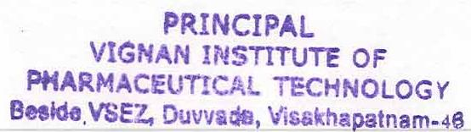

** VIGNAN INSTITUTE OF PHARMACEUTICAL TECHNOLOGY**

[www.vignanpharma.com](http://www.vignanpharma.com) (Approved by AICTE, PCI New Delhi & Affiliated to JNTUK). Estd.2006.

An ISO 9001:2015, ISO 14001:2015, OHSAS 18001:2007 Certified Institution

Beside VSEZ,Kapujaggaraju peta Duvvada, Visakhapatnam-530049. A.P

Phone 0891-2511222/2589777, Fax: 0891-2752333:: email : viptvizag@gmail.com

REPORT

Date: 06/07/2019

* Students were participated in dance solo and group event
* Students were participated in singing solo and group event







NSS Coordinator Principal

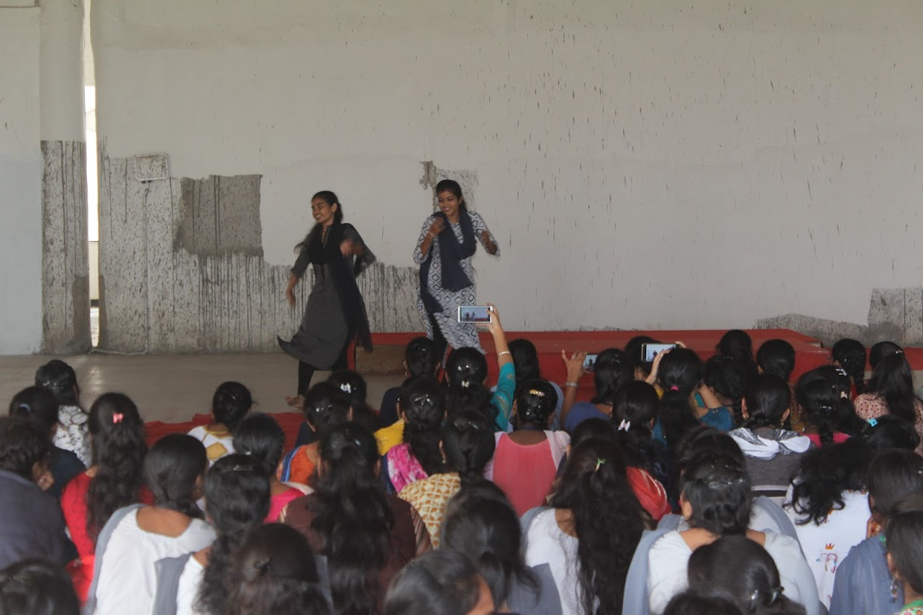

**Group dance**

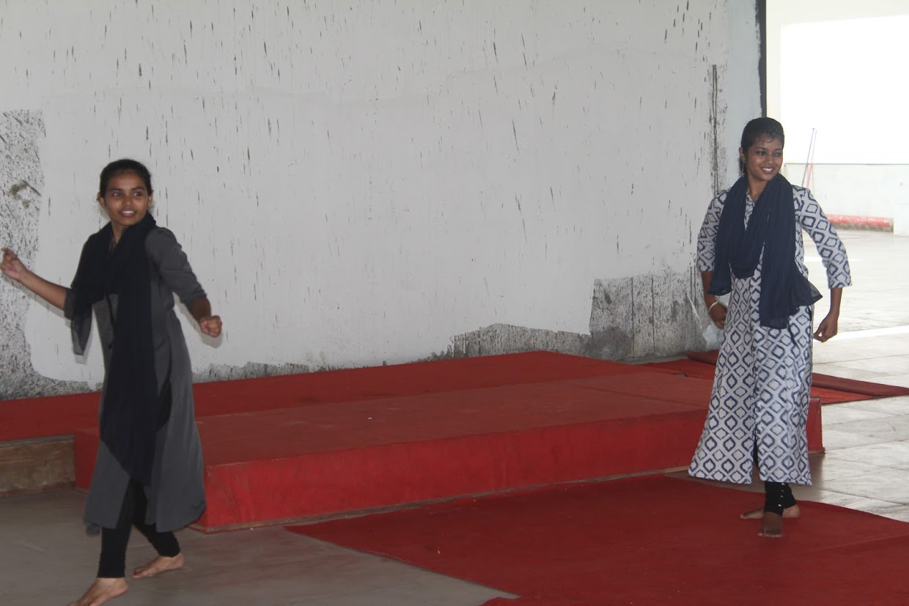

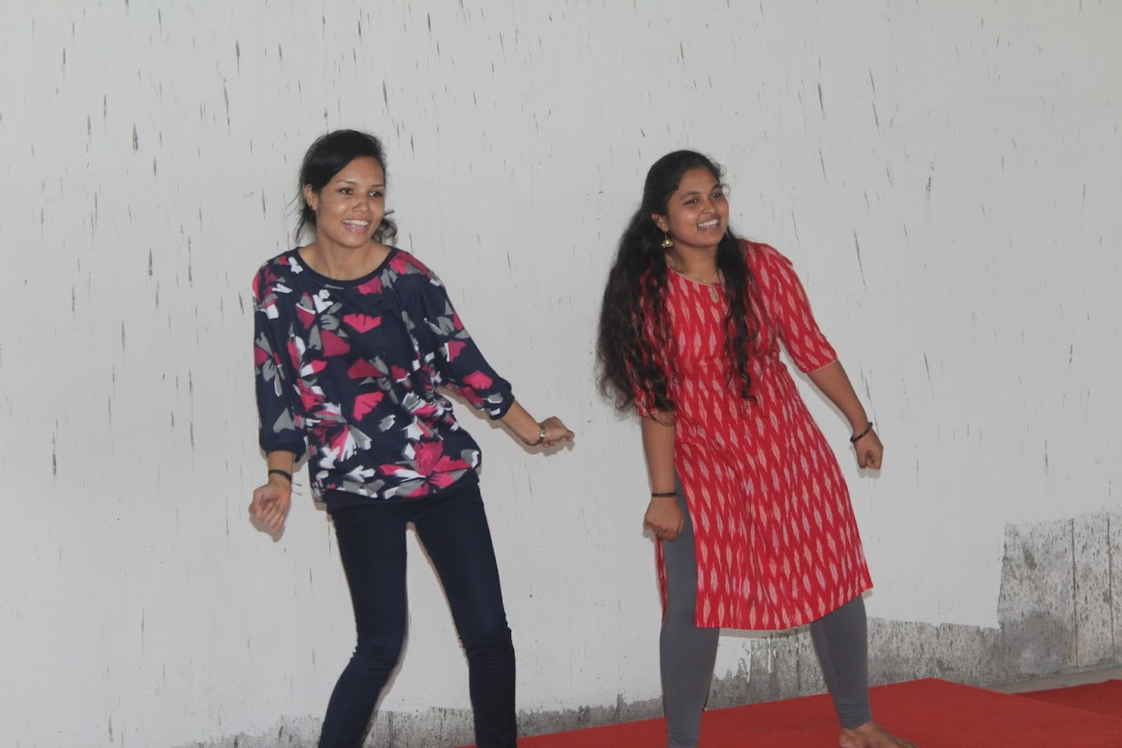

**Group dance**

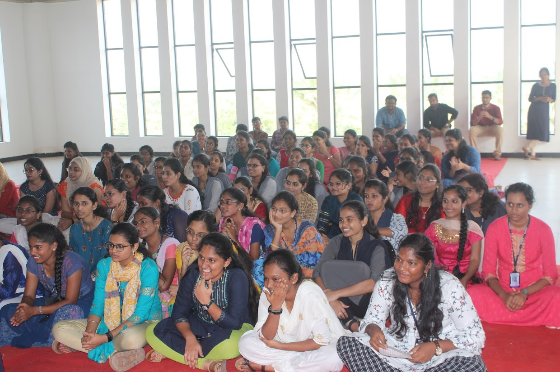

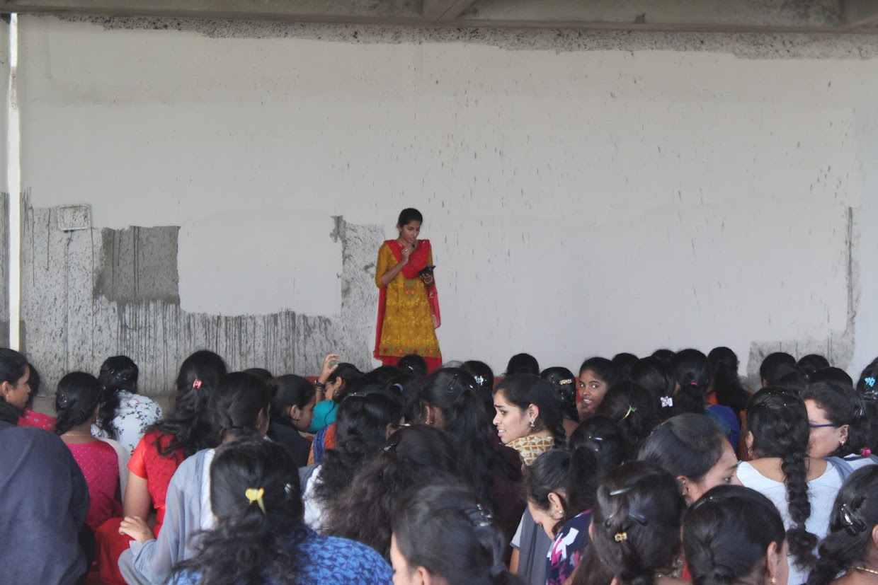

**Solo singing**

