*Student Activity Centre (SAC)*

29/06/2019





** VIGNAN INSTITUTE OF PHARMACEUTICAL TECHNOLOGY**

[www.vignanpharma.com](http://www.vignanpharma.com) (Approved by AICTE, PCI New Delhi & Affiliated to JNTUK). Estd.2006.

An ISO 9001:2015, ISO 14001:2015, OHSAS 18001:2007 Certified Institution

Beside VSEZ ,Kapujaggaraju peta Duvvada, Visakhapatnam-530049. A.P

Phone 0891-2511222/2589777, Fax: 0891-2752333:: email : viptvizag@gmail.com

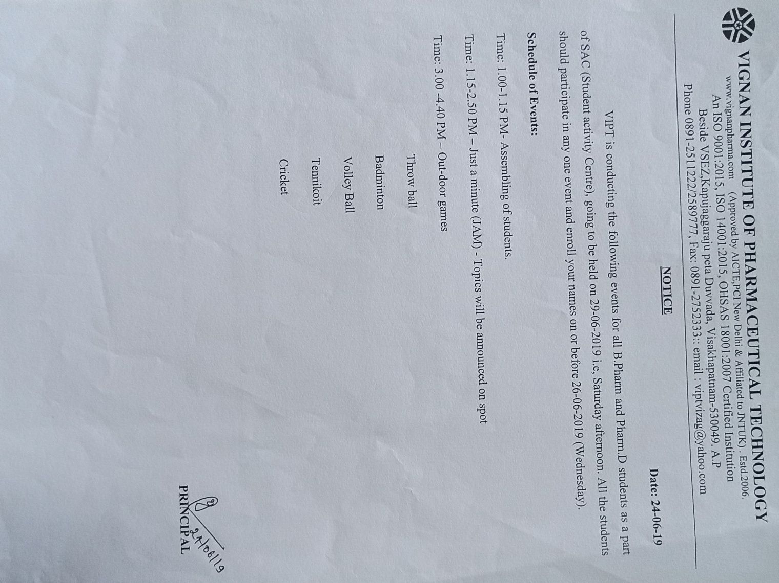

** VIGNAN INSTITUTE OF PHARMACEUTICAL TECHNOLOGY**

[www.vignanpharma.com](http://www.vignanpharma.com) (Approved by AICTE, PCI New Delhi & Affiliated to JNTUK). Estd.2006.

An ISO 9001:2015, ISO 14001:2015, OHSAS 18001:2007 Certified Institution

Beside VSEZ,Kapujaggaraju peta Duvvada, Visakhapatnam-530049. A.P

Phone 0891-2511222/2589777, Fax: 0891-2752333:: email : viptvizag@gmail.com

REPORT

Date: 29/06/2019

* Just a minute was held on Saturday under SAC.
* Outdoor games were conducted.







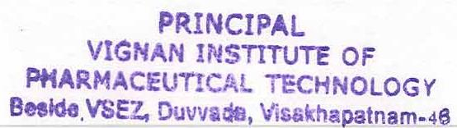NSS Coordinator Principal

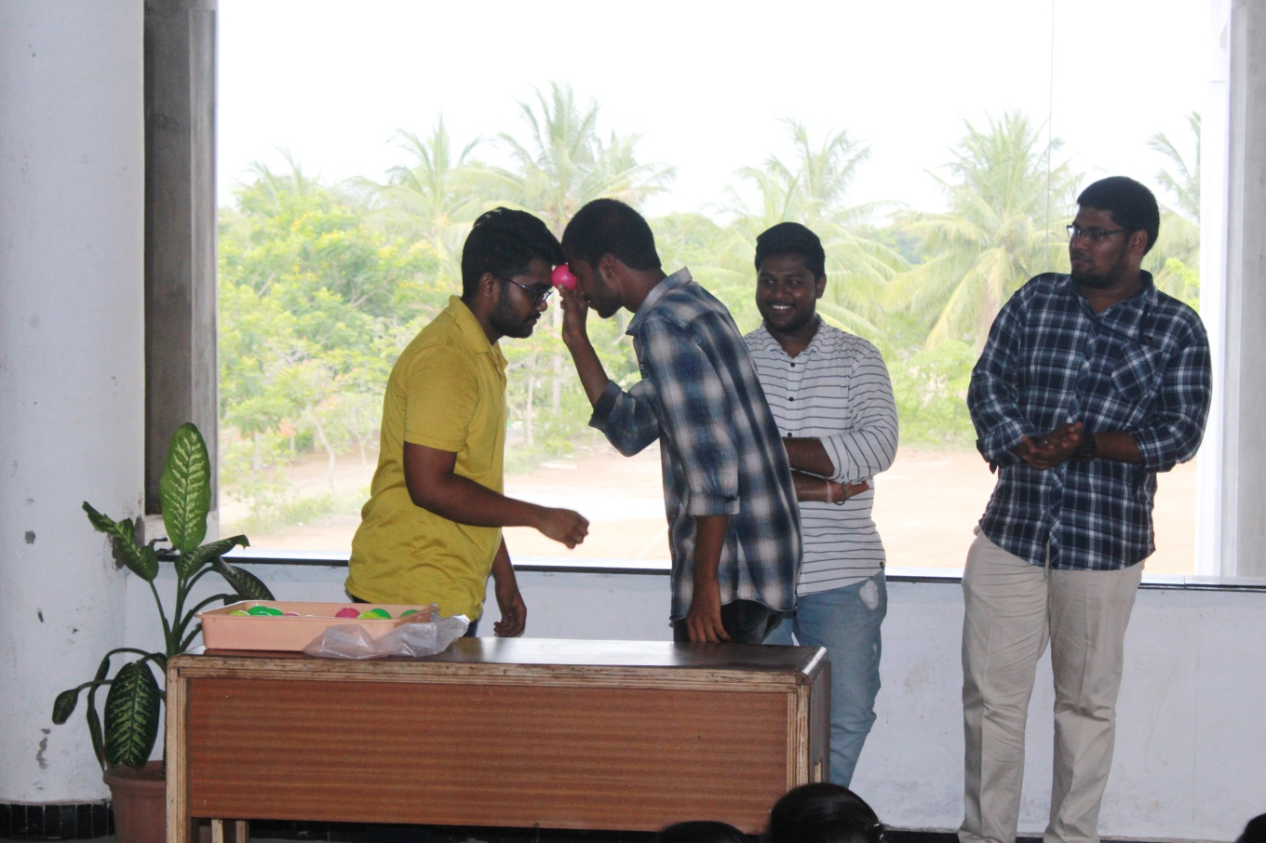

**Just a minute as a part of SAC**

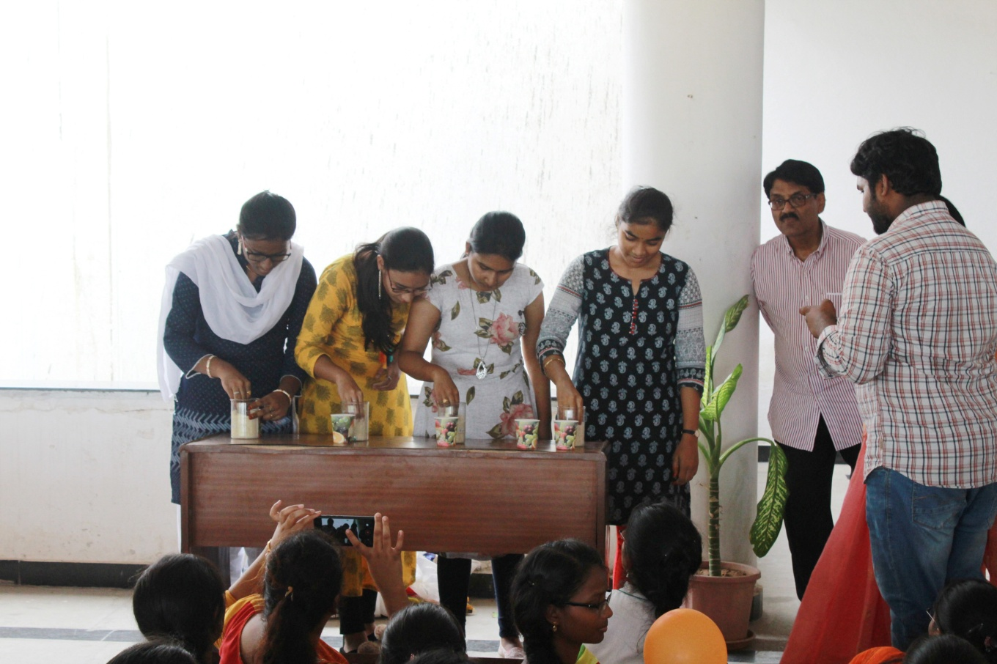

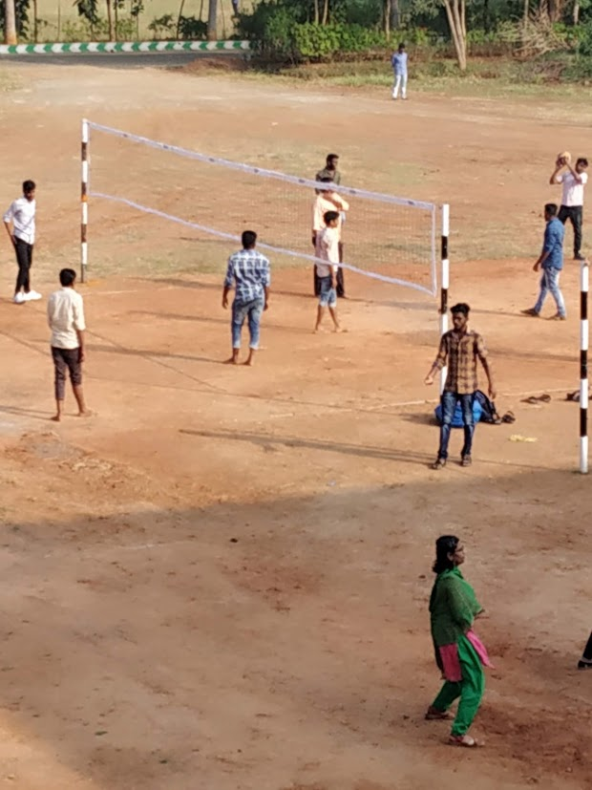

**Outdoor games to students**

