*Student Activity Centre (SAC)*

27/07/2019





** VIGNAN INSTITUTE OF PHARMACEUTICAL TECHNOLOGY**

[www.vignanpharma.com](http://www.vignanpharma.com) (Approved by AICTE, PCI New Delhi & Affiliated to JNTUK). Estd.2006.

An ISO 9001:2015, ISO 14001:2015, OHSAS 18001:2007 Certified Institution

Beside VSEZ ,Kapujaggaraju peta Duvvada, Visakhapatnam-530049. A.P

Phone 0891-2511222/2589777, Fax: 0891-2752333:: email : viptvizag@gmail.com

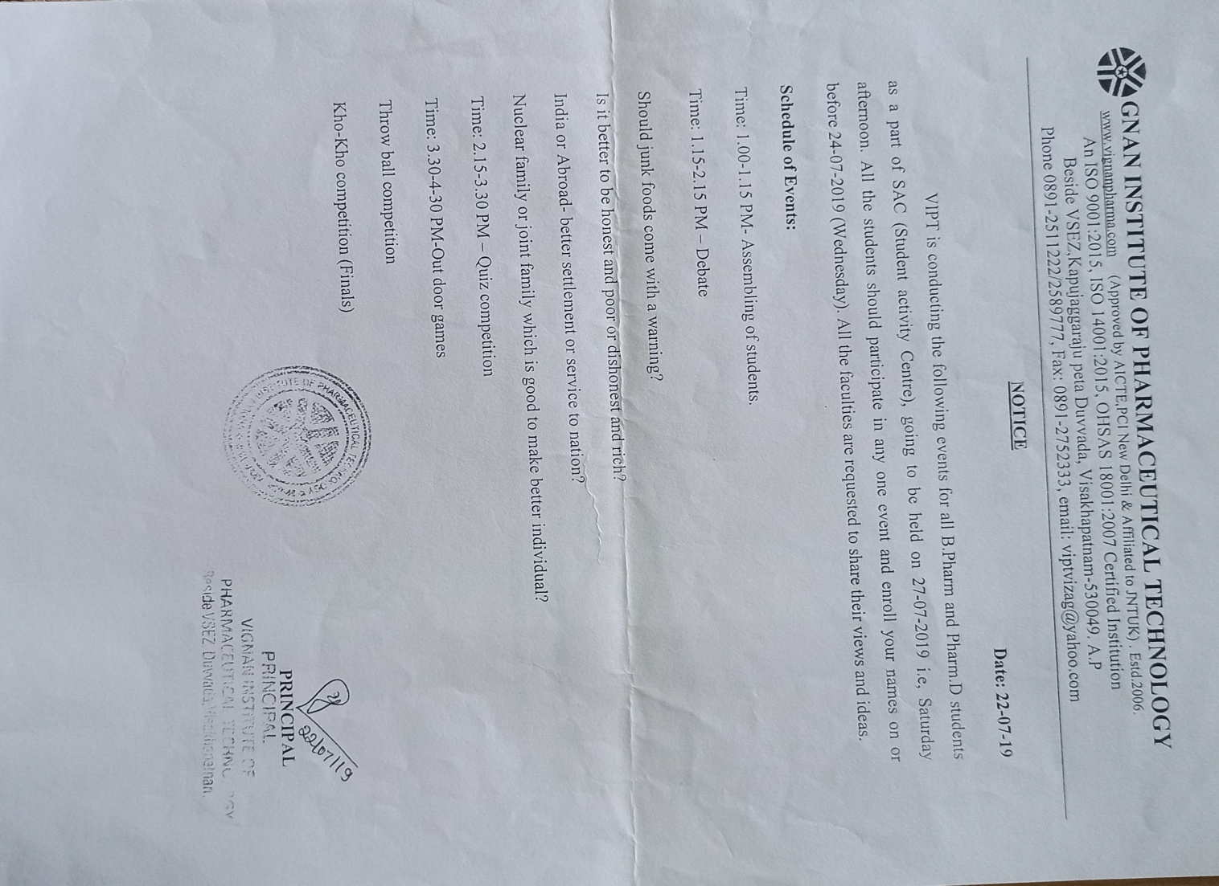

** VIGNAN INSTITUTE OF PHARMACEUTICAL TECHNOLOGY**

[www.vignanpharma.com](http://www.vignanpharma.com) (Approved by AICTE, PCI New Delhi & Affiliated to JNTUK). Estd.2006.

An ISO 9001:2015, ISO 14001:2015, OHSAS 18001:2007 Certified Institution

Beside VSEZ,Kapujaggaraju peta Duvvada, Visakhapatnam-530049. A.P

Phone 0891-2511222/2589777, Fax: 0891-2752333:: email : viptvizag@gmail.com

REPORT

Date: 27/07/2019

* Kho-Kho and throw ball finals were conducted to the winners of prelims.





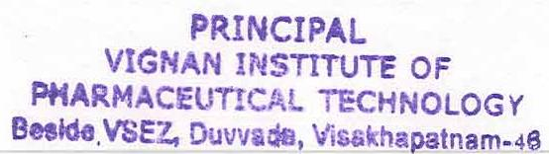 Principal

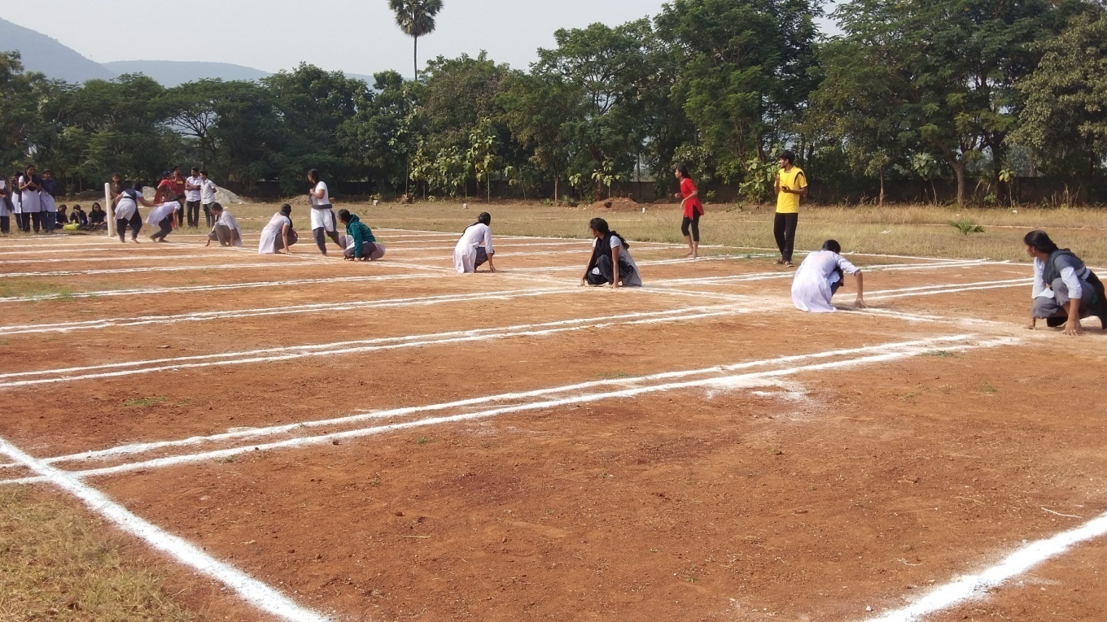

**Kho-kho finals**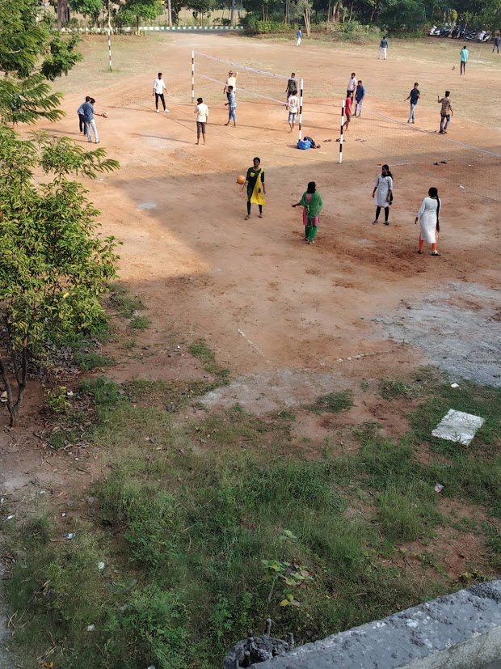

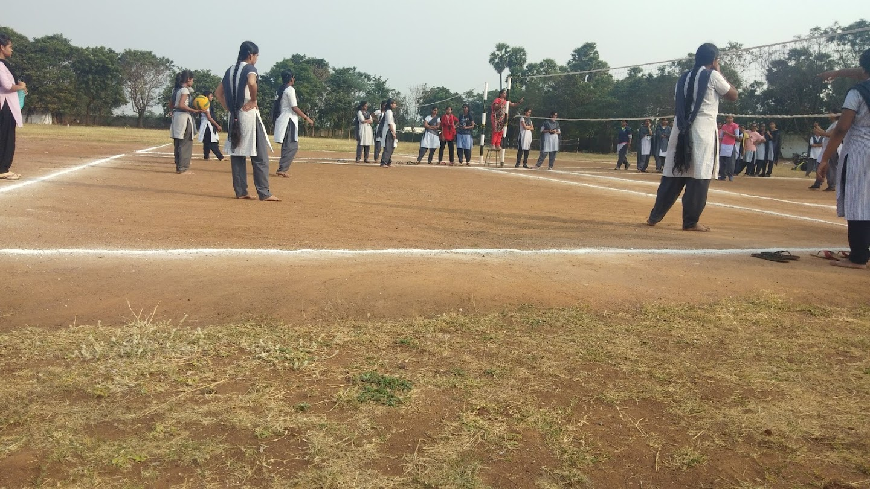

**Throw ball finals**

