Student Activity Centre (SAC)
20/07/2019

VIGNAN INSTITUTE OF PHARMACEUTICAL TECHNOLOGY
www.vignanpharma.com (Approved by AICTE, PCI New Delhi & Affiliated to JNTUK). Estd.2006.
An ISO 9001:2015, ISO 14001:2015, OHSAS 18001:2007 Certified Institution
Beside VSEZ ,Kapujaggaraju peta Duvvada, Visakhapatnam-530049. A.P
Phone 0891-2511222/2589777, Fax: 0891-2752333:: email : viptvizag@gmail.com

NOTICE

Date: 15/07/2019

VIPT is conducting the following events for all B.Pharm and Pharm.D students as a part of SAC (Student activity Centre), in association with NSS volunteers i.e, Saturday afternoon (20/07/2019). All the students should participate in the below events and enroll your names on or before 18-07-2019 (Thursday).
Theme:
Environment protection an recycling the waste
Events:
Elocution
Essay writing
Model exhibit

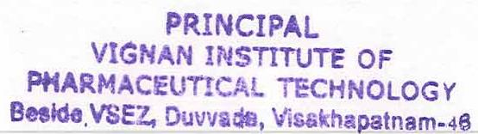
Principal
VIGNAN INSTITUTE OF PHARMACEUTICAL TECHNOLOGY
www.vignanpharma.com (Approved by AICTE, PCI New Delhi & Affiliated to JNTUK). Estd.2006.
An ISO 9001:2015, ISO 14001:2015, OHSAS 18001:2007 Certified Institution
Beside VSEZ,Kapujaggaraju peta Duvvada, Visakhapatnam-530049. A.P
Phone 0891-2511222/2589777, Fax: 0891-2752333:: email : viptvizag@gmail.com

REPORT

Date: 20/07/2019

- Welcome speech given by Principal Dr.Y.Srininvasa Rao
- Students were participated in the events in scheduled time.
- Prizes were distributed to winners.

Principal

Model exhibit
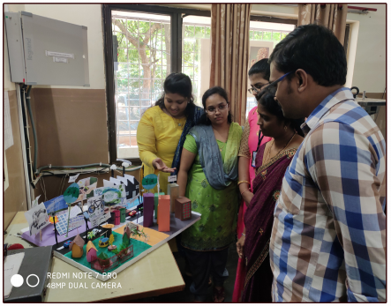

Essay writing

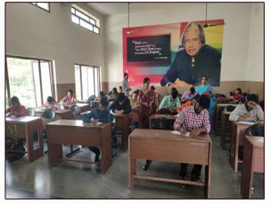

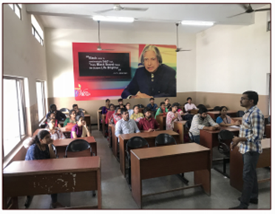

Elocution

