Student Activity Centre (SAC)
15/06/2019

VIGNAN INSTITUTE OF PHARMACEUTICAL TECHNOLOGY
www.vignanpharma.com (Approved by AICTE, PCI New Delhi & Affiliated to JNTUK). Estd.2006.
An ISO 9001:2015, ISO 14001:2015, OHSAS 18001:2007 Certified Institution
Beside VSEZ ,Kapujaggaraju peta Duvvada, Visakhapatnam-530049. A.P
Phone 0891-2511222/2589777, Fax: 0891-2752333:: email : viptvizag@gmail.com

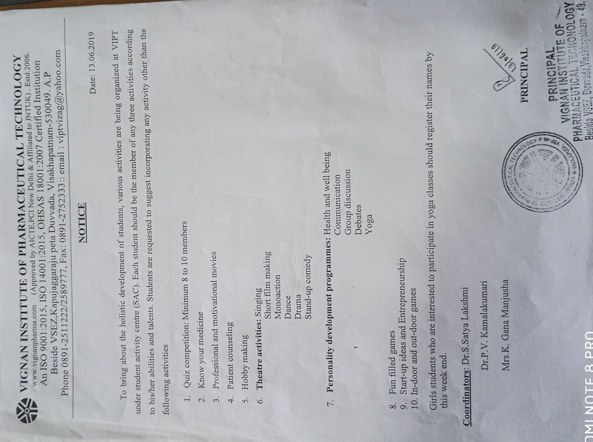

VIGNAN INSTITUTE OF PHARMACEUTICAL TECHNOLOGY
www.vignanpharma.com (Approved by AICTE, PCI New Delhi & Affiliated to JNTUK). Estd.2006.
An ISO 9001:2015, ISO 14001:2015, OHSAS 18001:2007 Certified Institution
Beside VSEZ,Kapujaggaraju peta Duvvada, Visakhapatnam-530049. A.P
Phone 0891-2511222/2589777, Fax: 0891-2752333:: email : viptvizag@gmail.com

REPORT

Date: 13/06/2019

- Sac was inaugurated by Principal Dr.Y.Srinivasa Rao.
- Principal addressed the gathering and discussed the importance of physical and cultural activities to students.
- Faculty and all the branches of students were participated in the inauguration.
- Sac activities were planned to conduct on every Saturday in the campus.
- Group discussion was conducted on first Saturday.

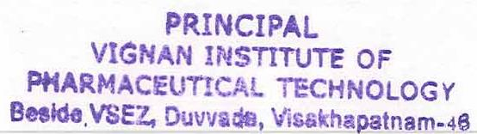
NSS Coordinator Principal

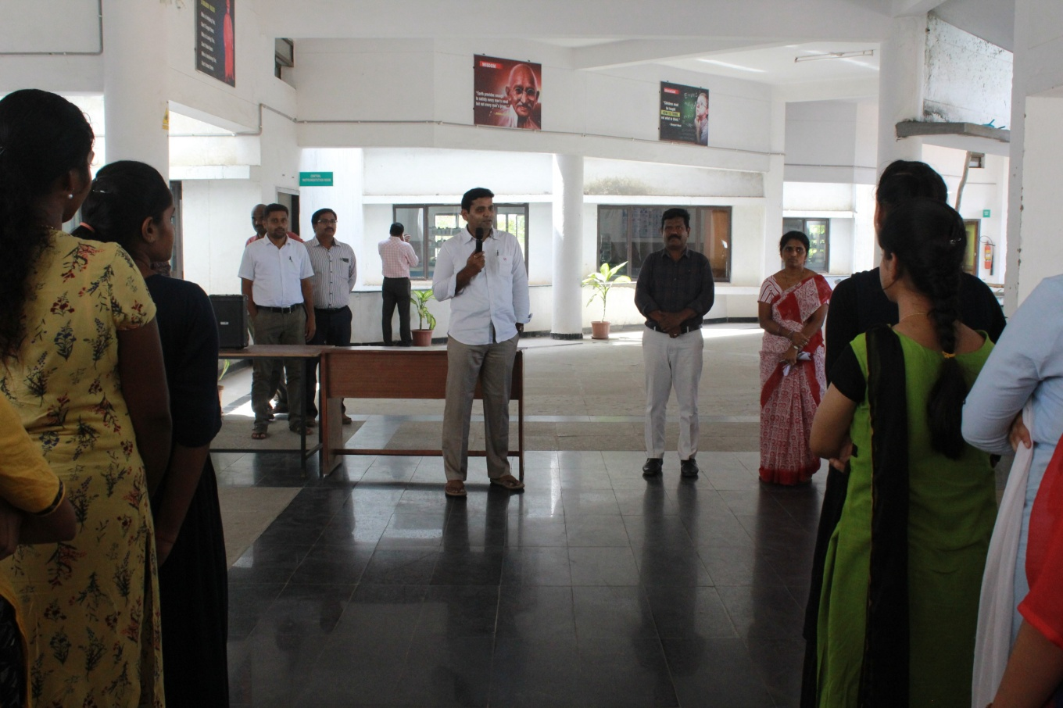
Addressing the gathering on the inauguration of SAC
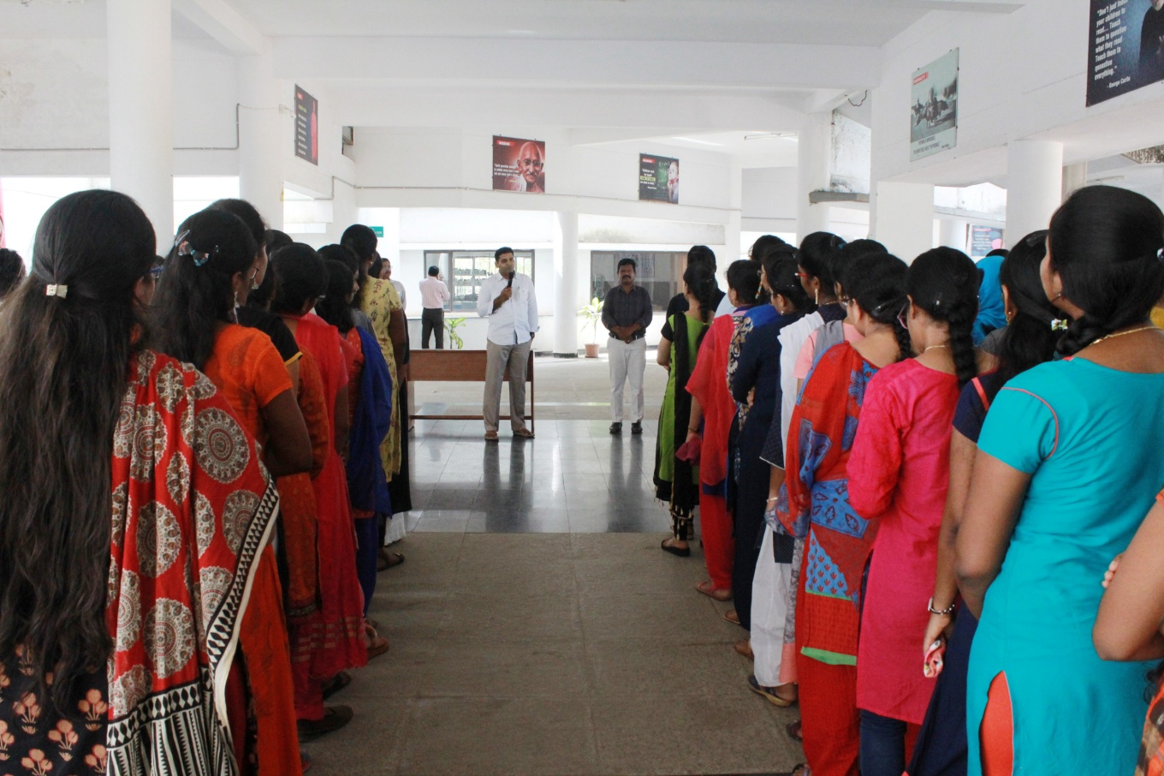

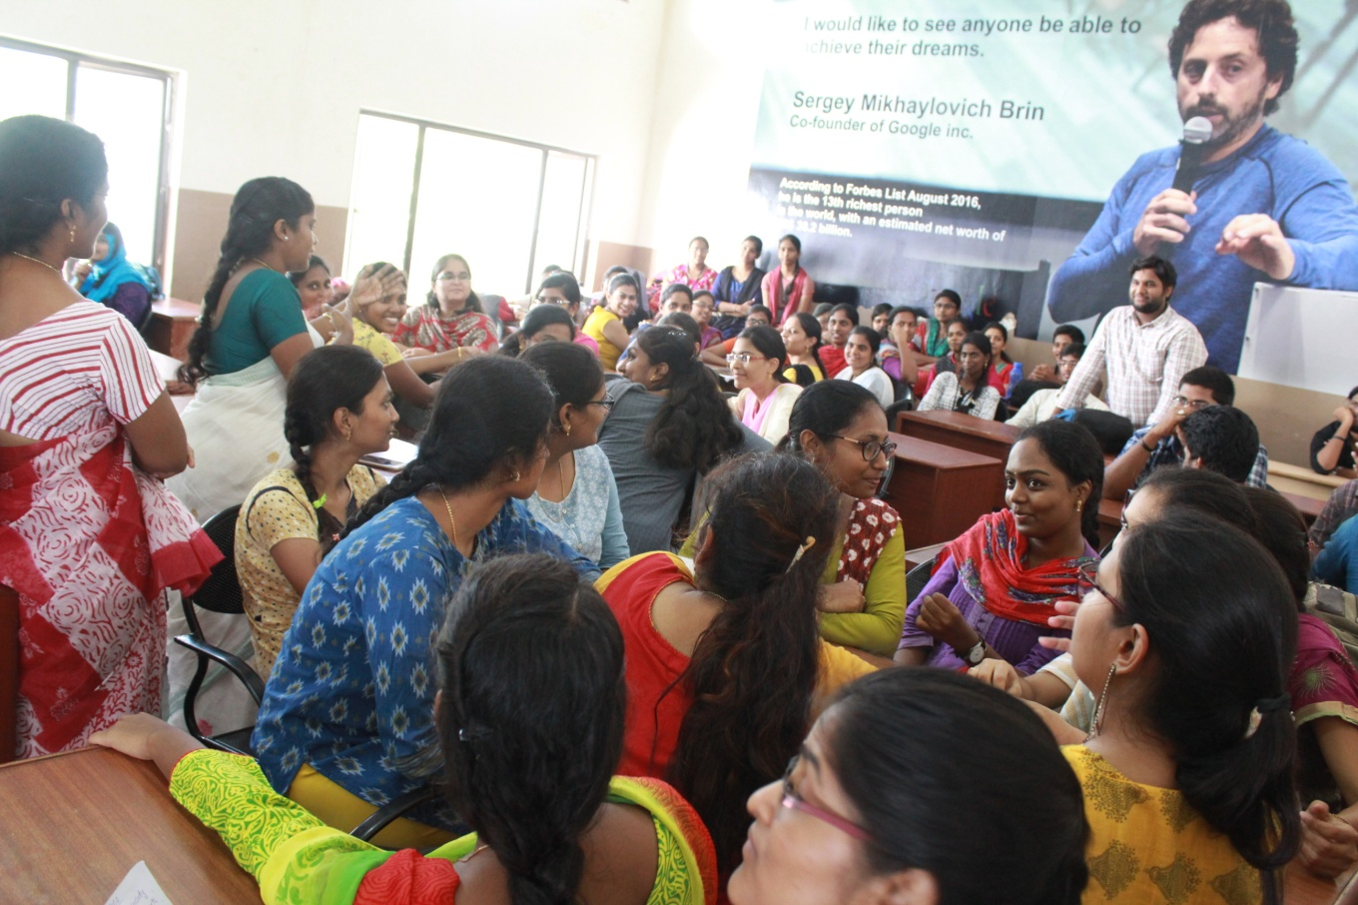

Group Discussion
