Yuvtarang
11/01/2020 to 12/01/2020

VIGNAN INSTITUTE OF PHARMACEUTICAL TECHNOLOGY
www.vignanpharma.com (Approved by AICTE, PCI New Delhi & Affiliated to JNTUK). Estd.2006.
An ISO 9001:2015, ISO 14001:2015, OHSAS 18001:2007 Certified Institution
Beside VSEZ,Kapujaggaraju peta Duvvada, Visakhapatnam-530049. A.P
Phone 0891-2511222/2589777, Fax: 0891-2752333:: email : viptvizag@gmail.com

Vignan group of Institutions has been organizing a national level sports and cultural fest, Yuvtarang for last 9 years. Budding pharmacists from various institutions across the nation have been participating in the event every year. Different sports and cultural competitions are being conducted by the organizing committee of Institute for two days.
Celebrities and outstanding personalities are being invited for the event to show their examples to the students so as to get motivated. As a part of Yuvtarang 2020, Dr.M.V.S.Prasad, Former Director of SHAR and Vice Chancellor of Vignan Deemed to University, Mr.Lavu Sri Krishnadevarayulu, Member of Parliament, Narsaraopeta, Mr.P.Vinod Kumar, CEO of NH-7, a unit of Rover Info Tech, Singapore, Mr.Chinthagunta Mallesham, Entrepreneur, Padmasri Awardees and creator of Laxmi Aasu Yanthram, Dr.K.Pavan, Innovator, Young Scientist and Entrepreneur, Tollywood Film Actors Naga Saurya, Krishnudu and playback singers Mr.Mallikarjun and Sravana Bhargavi participated in the event as Guests.
Around 2500 students from different Pharmacy and Engineering Institutions have participated in various sports and cultural events. Around 1000 students of the Institute have involved in various sports and cultural activities. Many students have performed special cultural shows for two days on stage. Around 50 students are involved in compering, 100 students to monitor discipline, 200 students in setting up business stalls and 50 students are involved for the coordination various sports and cultural events.

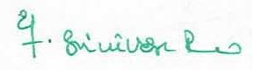
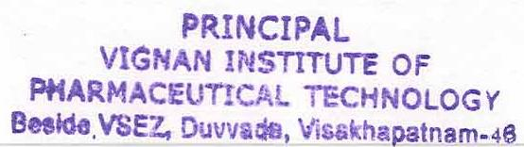
Principal

