World Pharmacists Day
25/09/2019

VIGNAN INSTITUTE OF PHARMACEUTICAL TECHNOLOGY
www.vignanpharma.com (Approved by AICTE, PCI New Delhi & Affiliated to JNTUK). Estd.2006.
An ISO 9001:2015, ISO 14001:2015, OHSAS 18001:2007 Certified Institution
Beside VSEZ ,Kapujaggaraju peta Duvvada, Visakhapatnam-530049. A.P
Phone 0891-2511222/2589777, Fax: 0891-2752333:: email : viptvizag@gmail.com

NOTICE

Date: 24/09/2019

Vignan Institute of Pharmaceutical Technology going to conduct World Pharmacists Day on 25/09/2019 in our college campus. All the students are informed to participate in various competitions on this occasion.

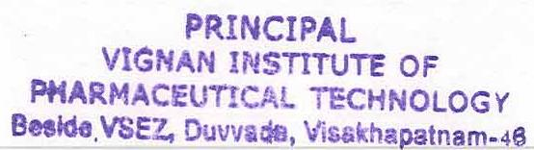
Principal

VIGNAN INSTITUTE OF PHARMACEUTICAL TECHNOLOGY
www.vignanpharma.com (Approved by AICTE, PCI New Delhi & Affiliated to JNTUK). Estd.2006.
An ISO 9001:2015, ISO 14001:2015, OHSAS 18001:2007 Certified Institution
Beside VSEZ,Kapujaggaraju peta Duvvada, Visakhapatnam-530049. A.P
Phone 0891-2511222/2589777, Fax: 0891-2752333:: email : viptvizag@gmail.com

REPORT

Date: 25/09/2019

- Students were participated in competitions conducted from morning to evening.
- Pharma quiz, Elocution, Rangoli and model exhibit were organized.
- For winners prizes were distributed in Valedictory.
- HOD, Pharm.D HOD and other faculty member were involved in prize distribution.

Principal
