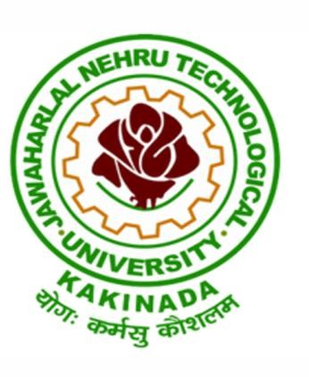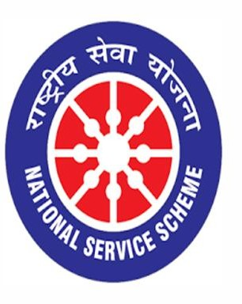

Sankranti Celebrations
11/01/2020

VIGNAN INSTITUTE OF PHARMACEUTICAL TECHNOLOGY
www.vignanpharma.com (Approved by AICTE, PCI New Delhi & Affiliated to JNTUK). Estd.2006.
An ISO 9001:2015, ISO 14001:2015, OHSAS 18001:2007 Certified Institution
Beside VSEZ,Kapujaggaraju peta Duvvada, Visakhapatnam-530049. A.P
Phone 0891-2511222/2589777, Fax: 0891-2752333:: email : viptvizag@gmail.com

REPORT

Date: 11/01/2020

Vignan Institute of Pharmaceutical Technology has organized Sankranti Celebrations at its premises on 11-01-2019. All the students and faculty came in traditional wear and created festive atmosphere in the campus. Lavu Sri Krishna Devarayalu MP has lit up the Campfire. Fuculty were involved in making of pongal and tug of war. Competitions were conducted to student’s pot painting, mehendi and rangoli. Prizes were distributed to winners.

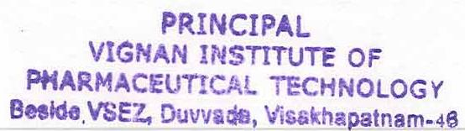
Principal
