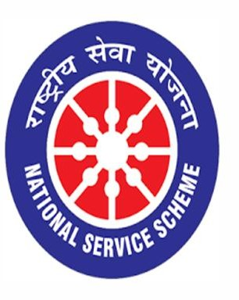

TREE PLANTATION
11/08/2020

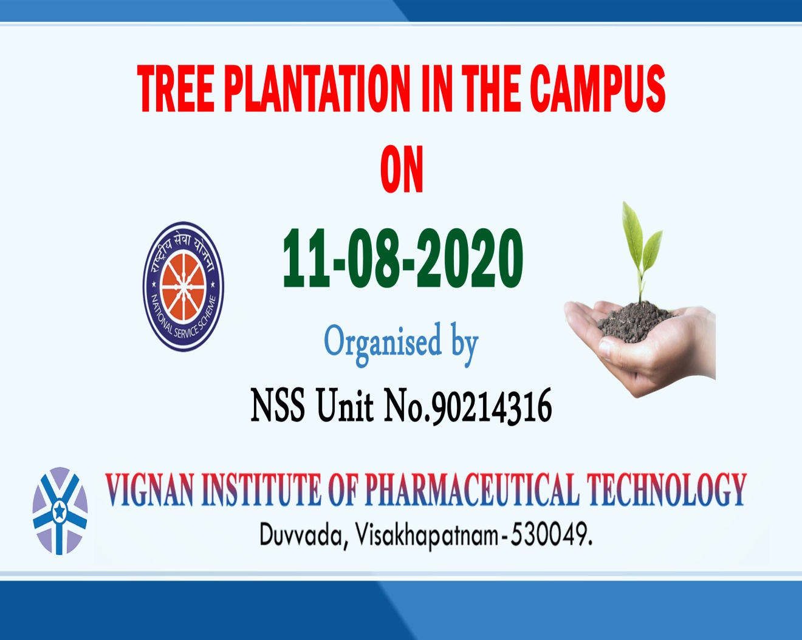

VIGNAN INSTITUTE OF PHARMACEUTICAL TECHNOLOGY
www.vignanpharma.com (Approved by AICTE,PCI New Delhi & Affiliated to JNTUK) . Estd.2006.
An ISO 9001:2015, ISO 14001:2015, OHSAS 18001:2007 Certified Institution
Beside VSEZ,Kapujaggaraju peta Duvvada, Visakhapatnam-530049. A.P
Phone 0891-2511222/2589777, Fax: 0891-2752333:: email : viptvizag@gmail.com

REPORT

- Principal, NSS Coordinator and staff were involved in this event

- Planted different medicinal value containing plants in the campus

- Took necessary measures like fencing, and watering for survival of plants

NSS Coordinator Principal
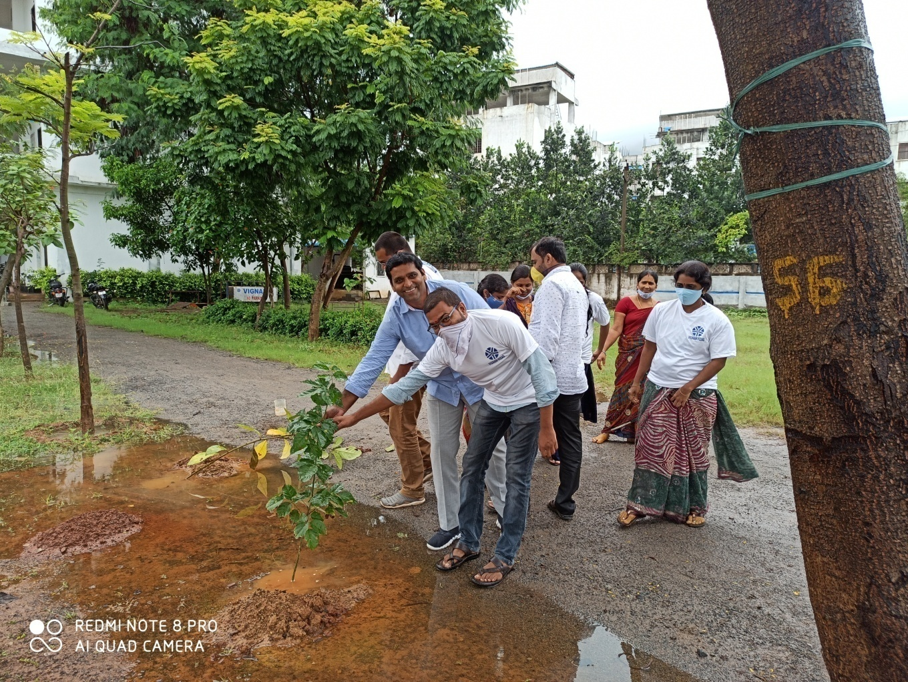
Plantation of Tree Saplings in VIPT Campus
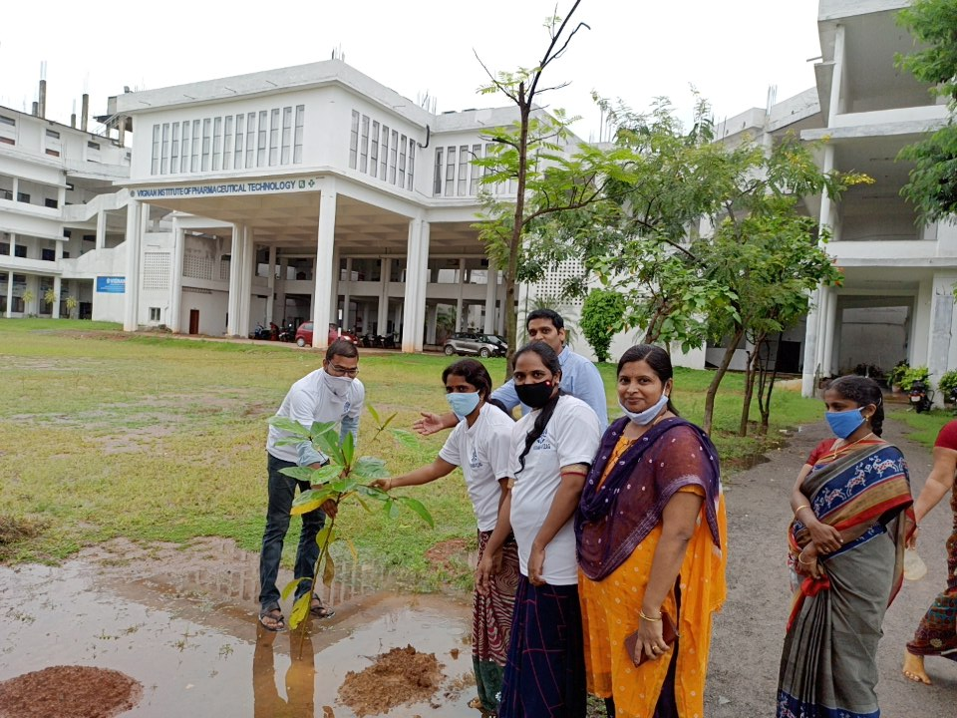
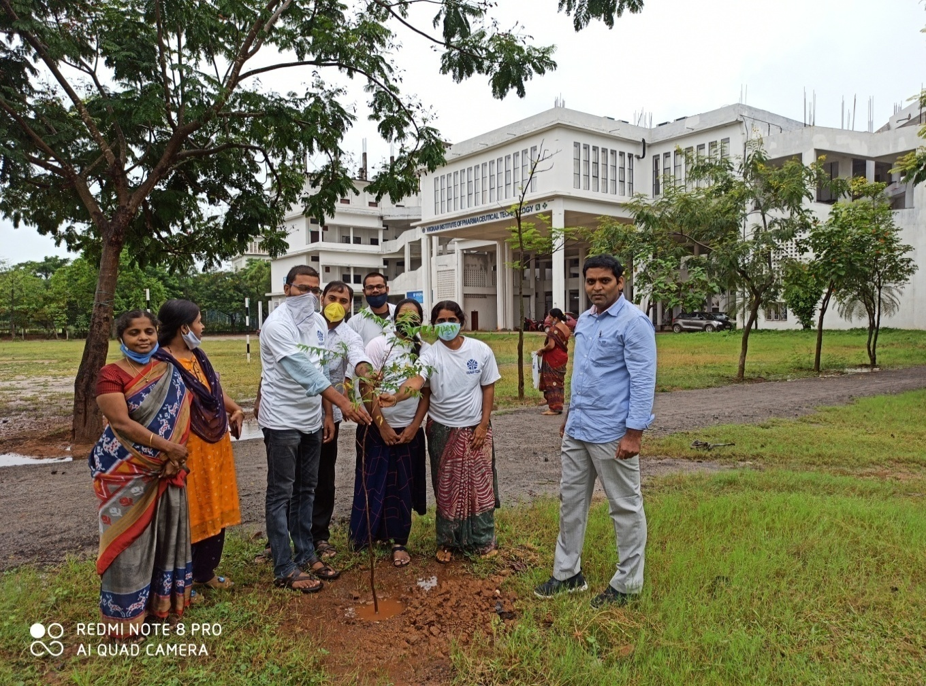
Plantation of Tree Saplings in VIPT Campus
