Christmas Celebrations
17/12/2019

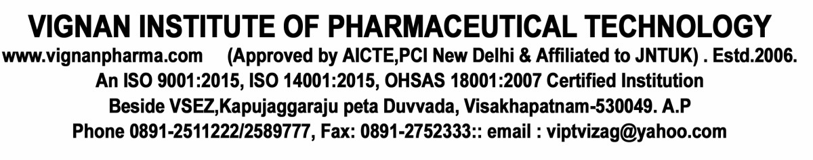

VIGNAN INSTITUTE OF PHARMACEUTICAL TECHNOLOGY
www.vignanpharma.com (Approved by AICTE,PCI New Delhi & Affiliated to JNTUK) . Estd.2006.
An ISO 9001:2015, ISO 14001:2015, OHSAS 18001:2007 Certified Institution
Beside VSEZ,Kapujaggaraju peta Duvvada, Visakhapatnam-530049. A.P
Phone 0891-2511222/2589777, Fax: 0891-2752333:: email : viptvizag@gmail.com

REPORT

Date: 17/12/2019

Vignan Institute of Institute of Pharmaceutical Technology has organized Christmas Celebrations at its premises on 17-12-2019. To sensitize students towards Indian festivals. Mr.Sunny Joseph Journalist and Chief Guest of the event has addressed the students. He motivated our students by sharing his personnel experiences. Students sung some prayer songs and Christmas cake was cut by HOD and Chief guest then distributed to students.

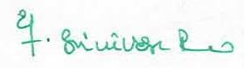
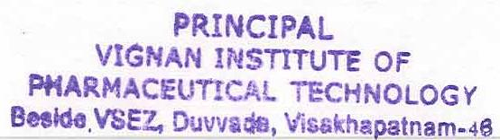
Principal

