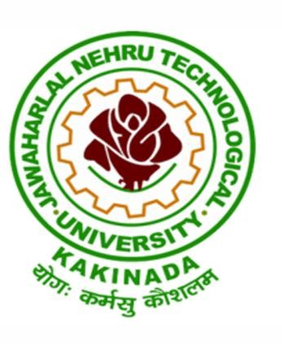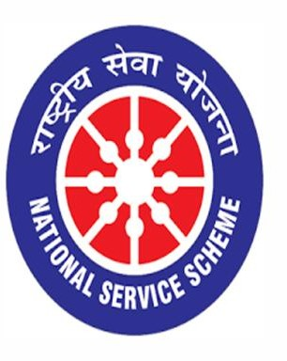

World Pharmacists Day
25/09/2020

VIGNAN INSTITUTE OF PHARMACEUTICAL TECHNOLOGY
www.vignanpharma.com (Approved by AICTE, PCI New Delhi & Affiliated to JNTUK). Estd.2006.
An ISO 9001:2015, ISO 14001:2015, OHSAS 18001:2007 Certified Institution
Beside VSEZ ,Kapujaggaraju peta Duvvada, Visakhapatnam-530049. A.P
Phone 0891-2511222/2589777, Fax: 0891-2752333:: email : viptvizag@gmail.com

NOTICE

Date: 19/09/2020
Dear Pharma fraternity,
This is to inform that VIGNAN INSTITUTE OF PHARMACEUTICAL TECHNOLOGY will be organizing different activities on the occasion of “World Pharmacists Day-2020” on 25.09.2020.
No Registration fee for webinar and student events.
WEBINAR (both for Faculty and Students):
An International Webinar on the World Pharmacists Day-2020 Theme: "Transforming Global Health" on 25.09.2020 at 10.00 AM is organized in association with the NSS unit, VIPT
Speaker: Dr. Venkata S Sabbisetti,
Harvard Institutes of Medicine, Boston, USA

This Webinar is open for all the Faculty Members, UG & PG Students of Pharmacy Department. Webinar is limited to 200 members only. Participants will earn e-certificates.

Events being conducted for the students:
1. Patient Counseling.
2. Medication Error Reporting.
3. Elocution on the theme.
4. Drawing competition on the theme.
5. Slogan Writing with justification.

A participation e-certificate will be provided for all the participants for each event. Winners and Runners will be provided with merit e-certificates also.

Interested candidates are requested to click on to the registration link provided below to enroll their names on or before 22.09.2020.
https://forms.gle/HNqcNTRA8i4NKpi28

Please contact the following numbers in case of any queries
1. Dr. S. Satyalakshmi - 8309504448
2. Mr.M. Vinodkumar - 7095197222
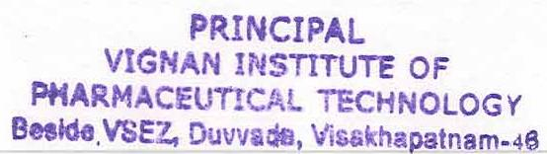
NSS Coordinator Principal

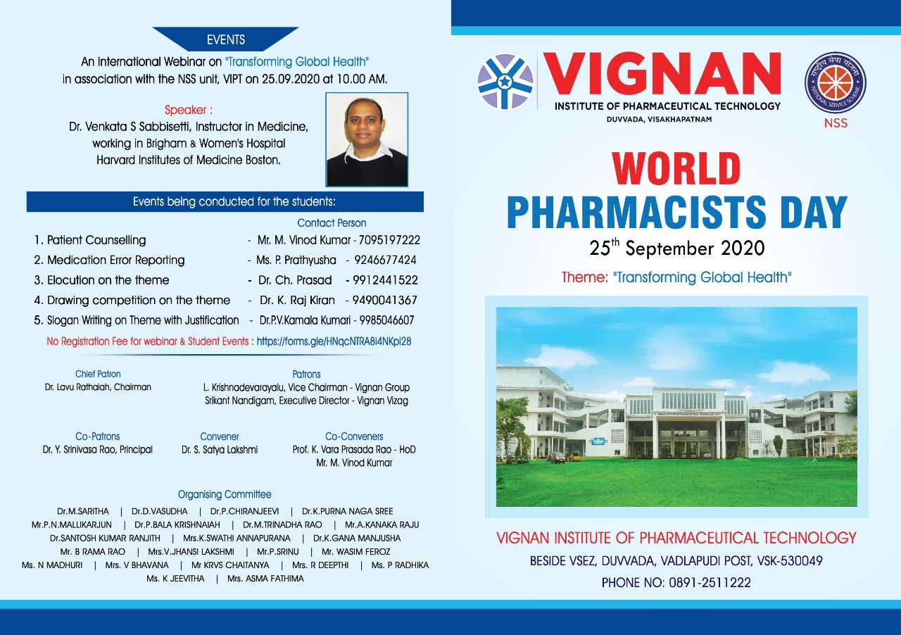
VIGNAN INSTITUTE OF PHARMACEUTICAL TECHNOLOGY
www.vignanpharma.com (Approved by AICTE, PCI New Delhi & Affiliated to JNTUK). Estd.2006.
An ISO 9001:2015, ISO 14001:2015, OHSAS 18001:2007 Certified Institution
Beside VSEZ,Kapujaggaraju peta Duvvada, Visakhapatnam-530049. A.P
Phone 0891-2511222/2589777, Fax: 0891-2752333:: email : viptvizag@gmail.com

REPORT

Date: 26/09/2020

- We got total 204 responses for various events.
- A total of 133 members were attended for webinar.
- Speaker explained the role of pharmacist in transforming global health.
- He is expert in diagnosis of Kidney Diseases and Fibrosis.
- He developed so many biomarkers for identification of kidney diseases.
- He shared his past experience the causes of kidney diseases of people living in Uddanam (Srikakulam-A.P).
- Afternoon student events were conducted.
- Students from more than10 different colleges were registered for various events.

NSS Coordinator Principal
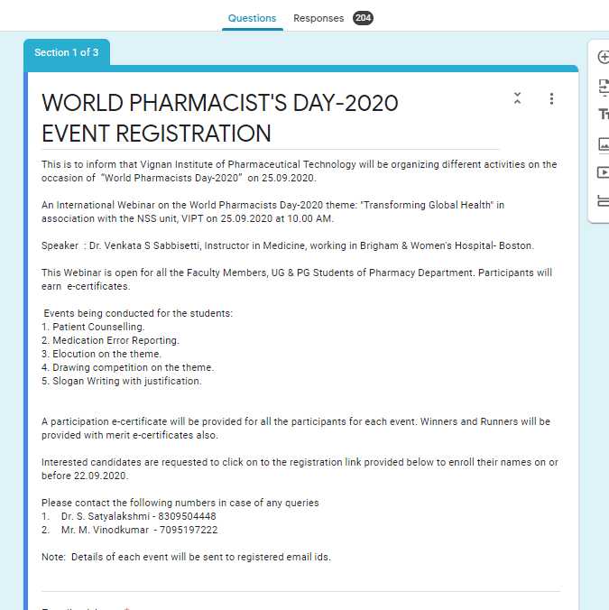

Responses for various events

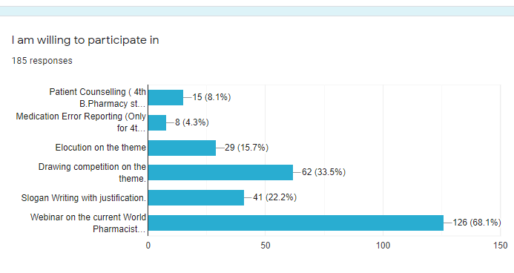

Webinar with total 133 participants

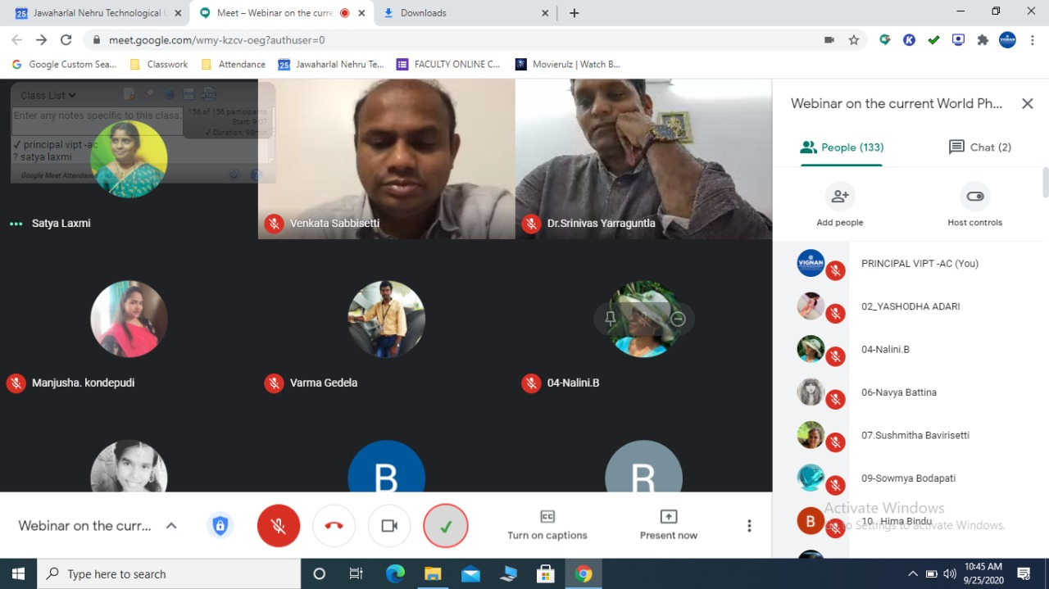

Slogan Writing
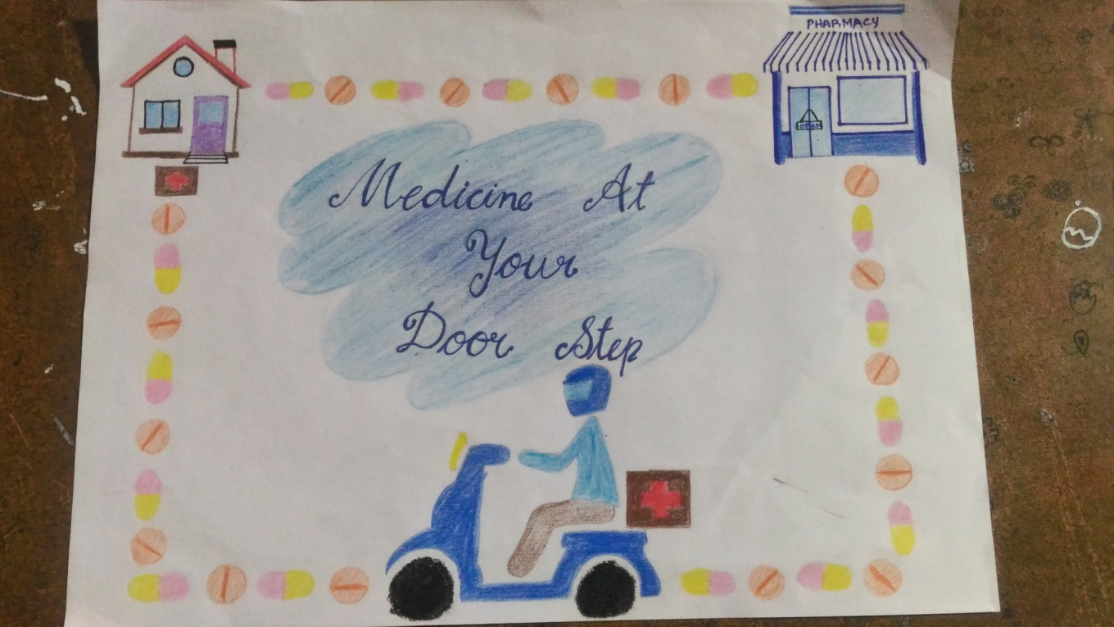

Drawing
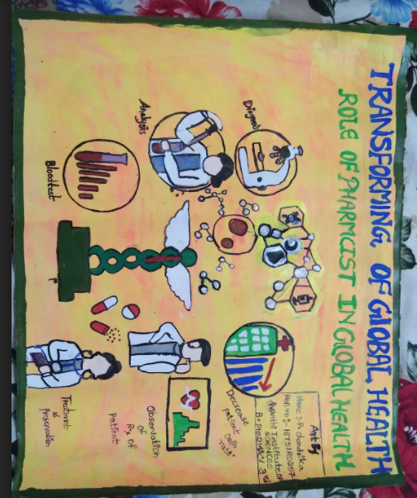

Elocution and Patient Counseling

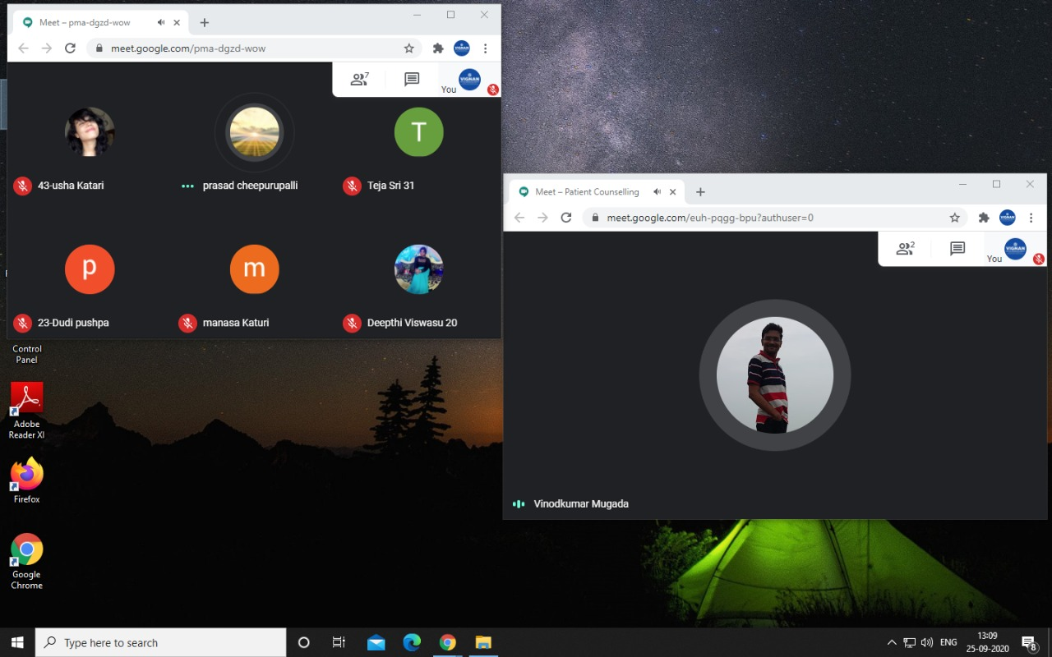

Certificate to Participants
