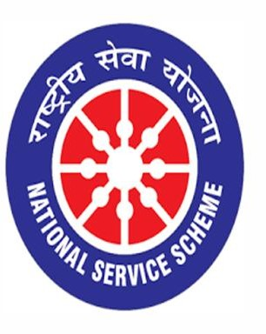

World Environment Day

05/06/2021

VIGNAN INSTITUTE OF PHARMACEUTICAL TECHNOLOGY
www.vignanpharma.com (Approved by AICTE,PCI New Delhi & Affiliated to JNTUK) . Estd.2006.
An ISO 9001:2015, ISO 14001:2015, OHSAS 18001:2007 Certified Institution
Beside VSEZ,Kapujaggaraju peta Duvvada, Visakhapatnam-530049. A.P
Phone 0891-2511222/2589777, Fax: 0891-2752333:: email : viptvizag@gmail.com

NOTICE

Date: 02/06/2021

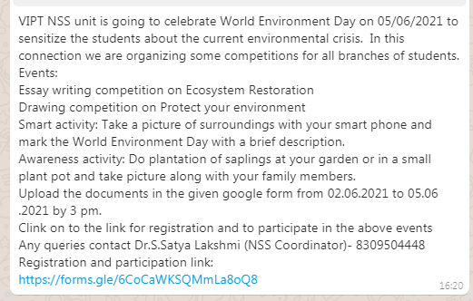

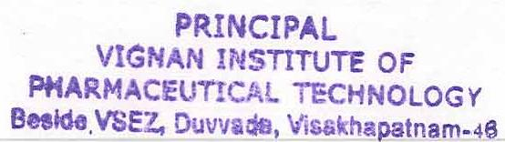
NSS Coordinator Principal
VIGNAN INSTITUTE OF PHARMACEUTICAL TECHNOLOGY
www.vignanpharma.com (Approved by AICTE,PCI New Delhi & Affiliated to JNTUK) . Estd.2006.
An ISO 9001:2015, ISO 14001:2015, OHSAS 18001:2007 Certified Institution
Beside VSEZ,Kapujaggaraju peta Duvvada, Visakhapatnam-530049. A.P
Phone 0891-2511222/2589777, Fax: 0891-2752333:: email : viptvizag@gmail.com

REPORT

Date: 05/06/2021

- Student participated in Events like Essay writing, Drawing competition, smart activity and Awareness program.
- All the branches of the students (B.Pharm, Pharm.D and M.Pharm) were participated.
- They uploaded their documents in google form.
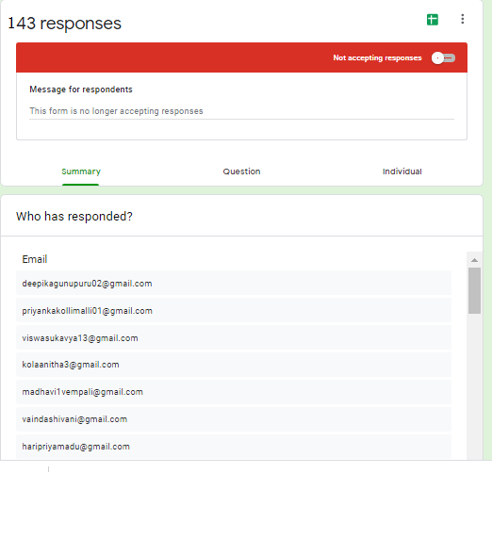

VIGNAN INSTITUTE OF PHARMACEUTICAL TECHNOLOGY
www.vignanpharma.com (Approved by AICTE,PCI New Delhi & Affiliated to JNTUK) . Estd.2006.
An ISO 9001:2015, ISO 14001:2015, OHSAS 18001:2007 Certified Institution
Beside VSEZ,Kapujaggaraju peta Duvvada, Visakhapatnam-530049. A.P
Phone 0891-2511222/2589777, Fax: 0891-2752333:: email : viptvizag@gmail.com

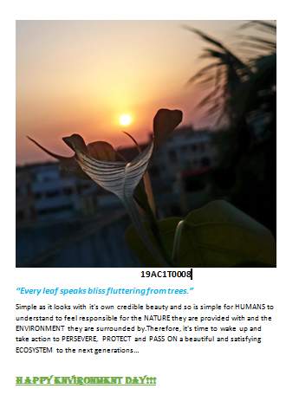
Smart activity by students
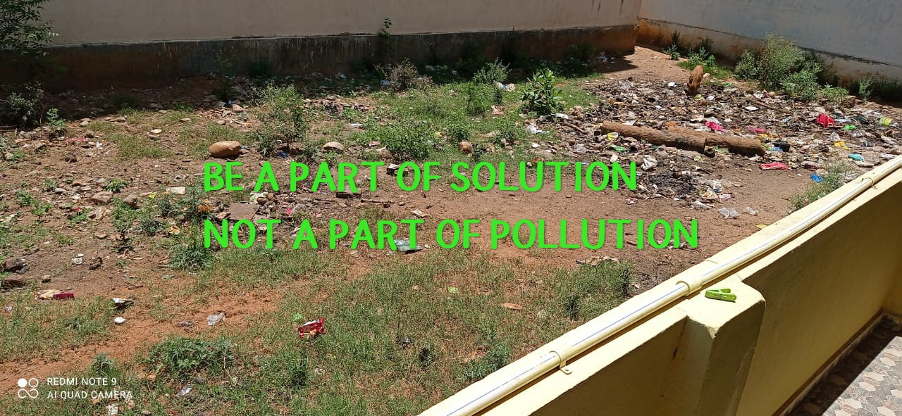

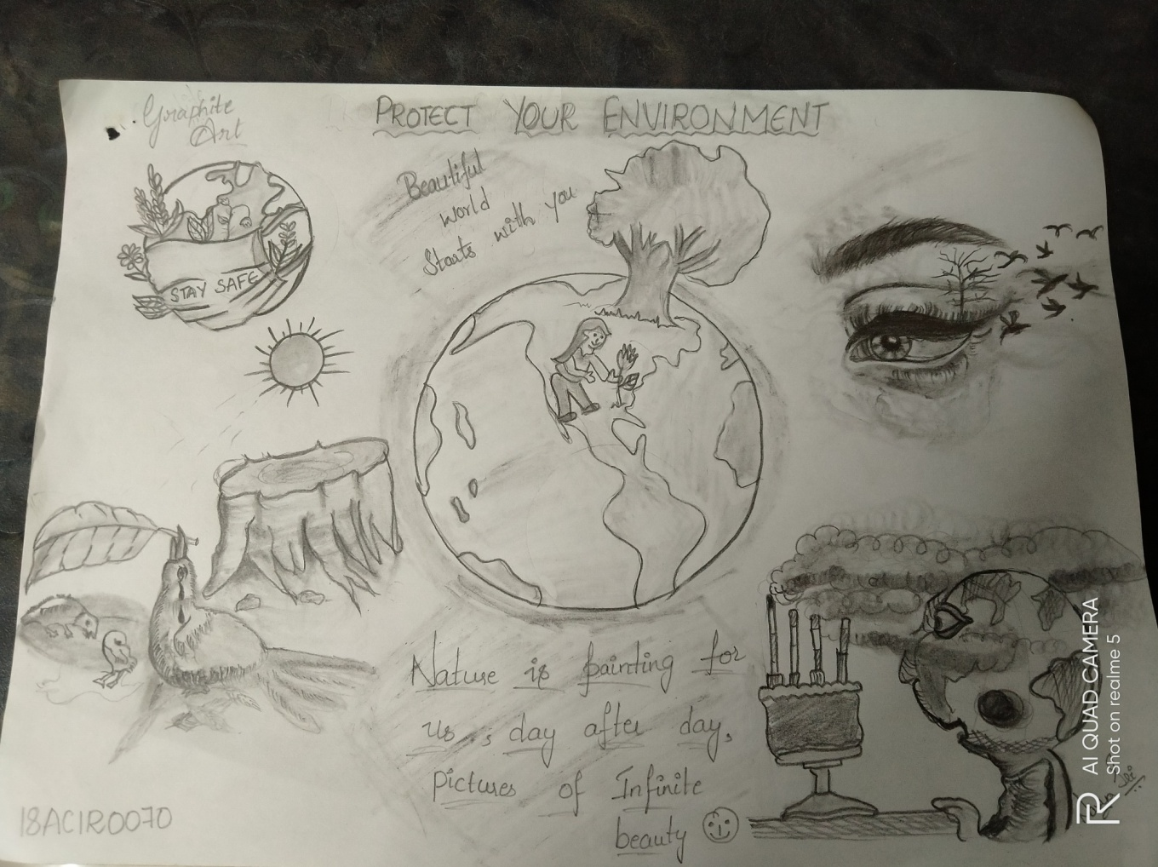
Students participated in drawing competition
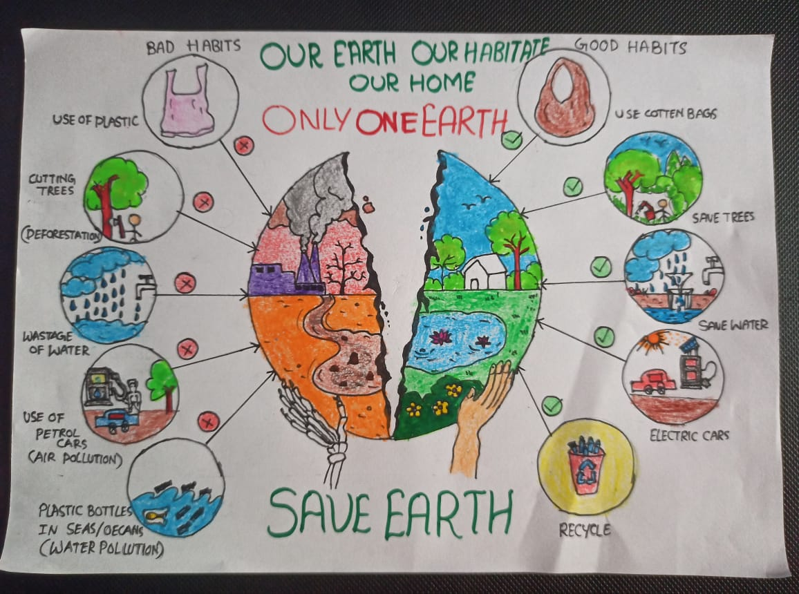
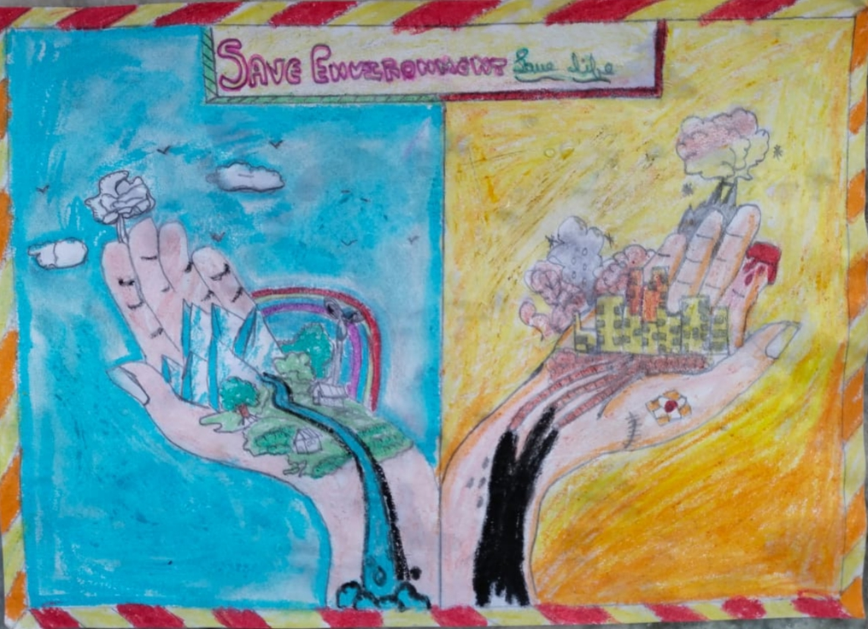
Students participated in drawing competition
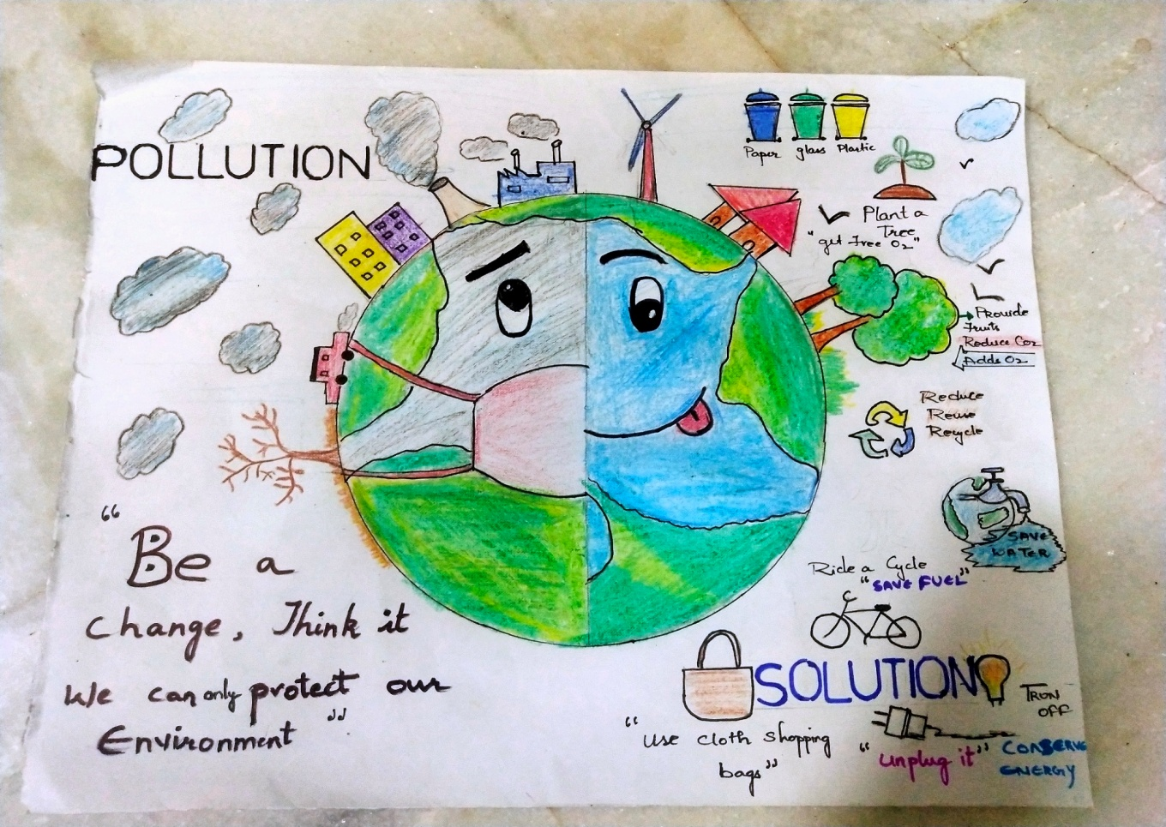
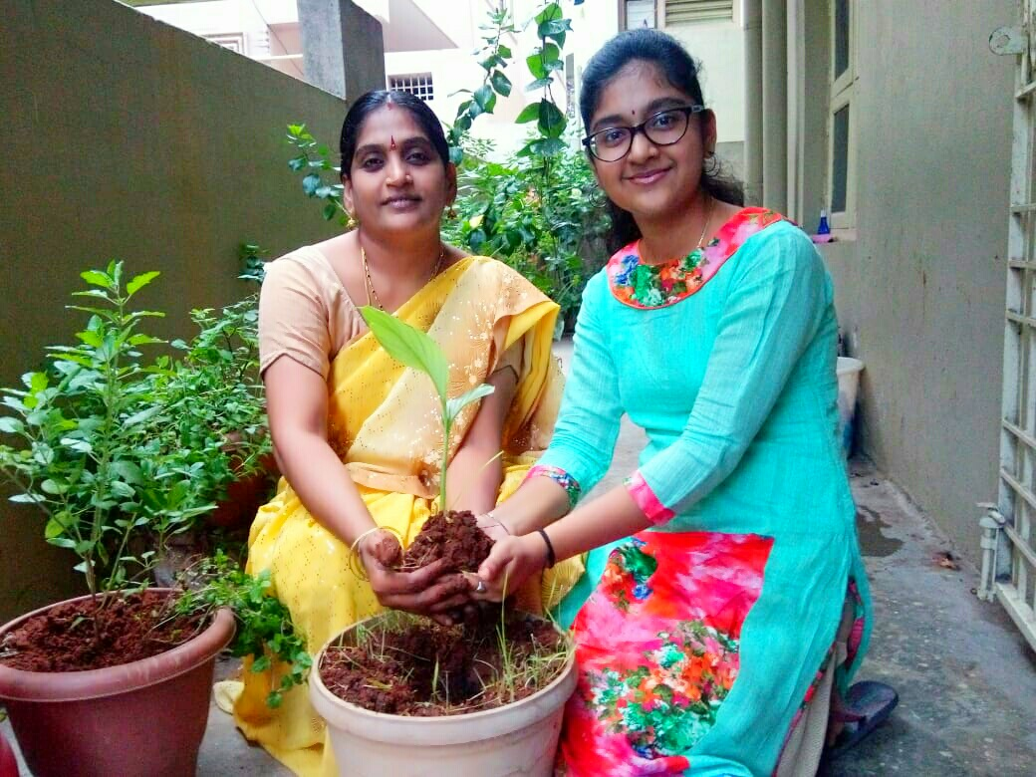

Plantation by students at home with their parents on WID

P
p

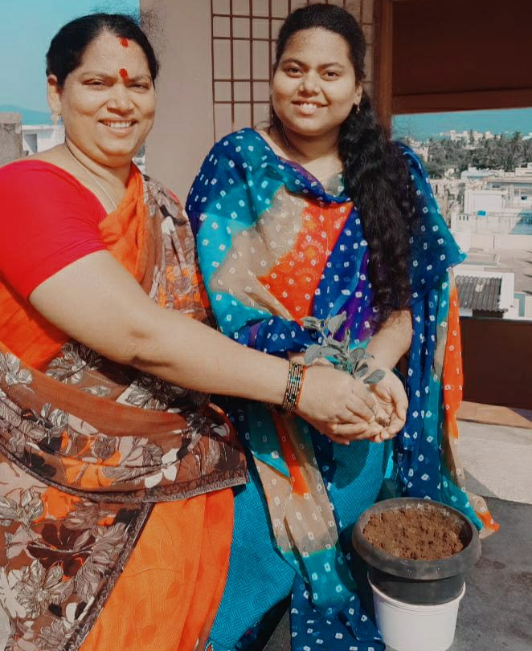
Plantation by students at home with their parents

