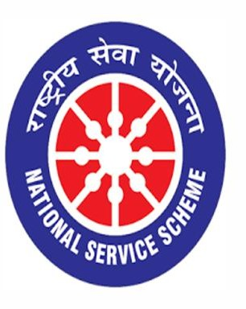

READING OF THE PREAMBLE
26/11/2020

VIGNAN INSTITUTE OF PHARMACEUTICAL TECHNOLOGY
www.vignanpharma.com (Approved by AICTE, PCI New Delhi & Affiliated to JNTUK). Estd.2006.
An ISO 9001:2015, ISO 14001:2015, OHSAS 18001:2007 Certified Institution
Beside VSEZ ,Kapujaggaraju peta Duvvada, Visakhapatnam-530049. A.P
Phone 0891-2511222/2589777, Fax: 0891-2752333:: email : viptvizag@gmail.com

NOTICE

Date: 24/11/2020

NSS unit of Vignan Institute of Pharmaceutical Technology going to conduct Reading of the Preamble of the Indian Constitution on 26/11/2020 in our college campus. All the students and faculty are informed to participate in this event.

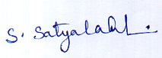
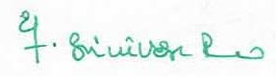
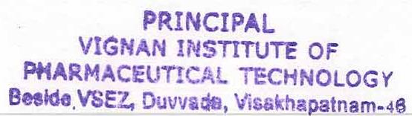
NSS Coordinator Principal

VIGNAN INSTITUTE OF PHARMACEUTICAL TECHNOLOGY
www.vignanpharma.com (Approved by AICTE, PCI New Delhi & Affiliated to JNTUK). Estd.2006.
An ISO 9001:2015, ISO 14001:2015, OHSAS 18001:2007 Certified Institution
Beside VSEZ,Kapujaggaraju peta Duvvada, Visakhapatnam-530049. A.P
Phone 0891-2511222/2589777, Fax: 0891-2752333:: email : viptvizag@gmail.com

REPORT

Date: 26/11/2020

The Preamble of the Indian Constitution was read by all the B.Pharm and Pharm.D students in their respective class rooms in presence of faculty members.

NSS Coordinator Principal
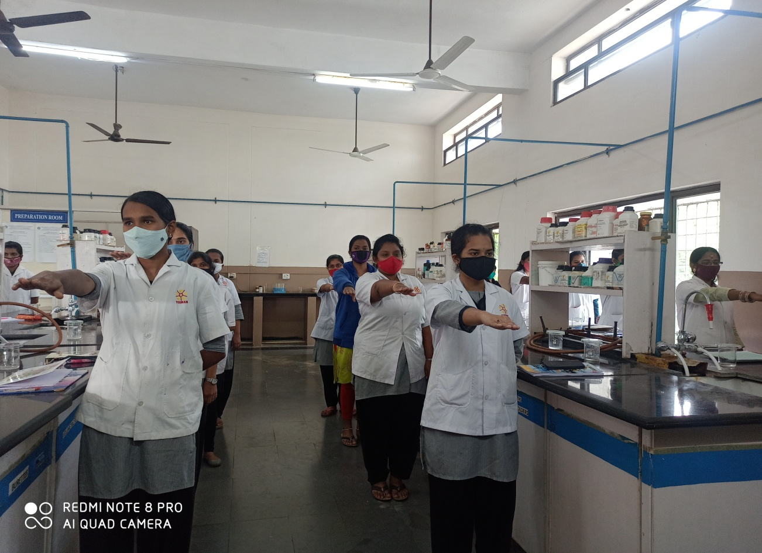

Reading of Preamble by B.Pharm students in Lab

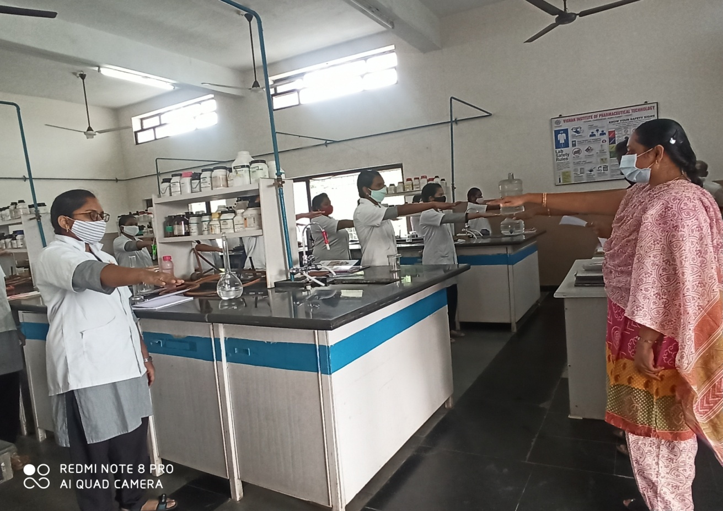

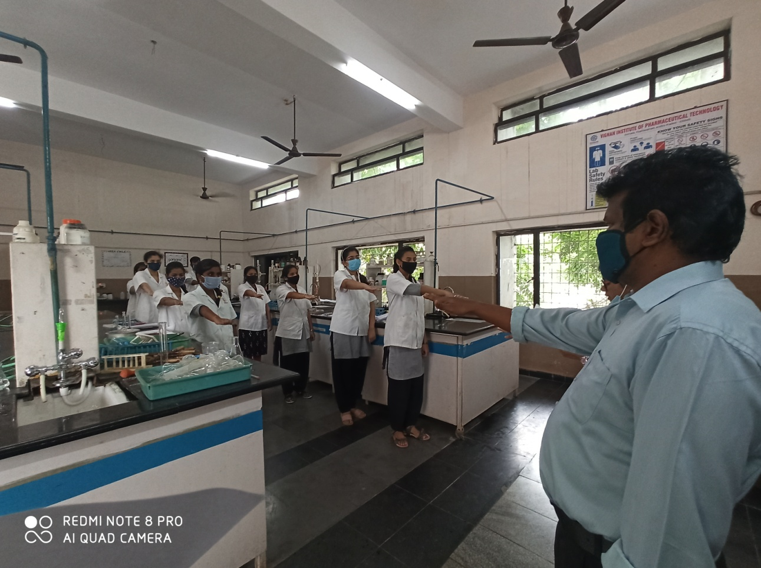

Reading of Preamble by B.Pharm and Pharm D students

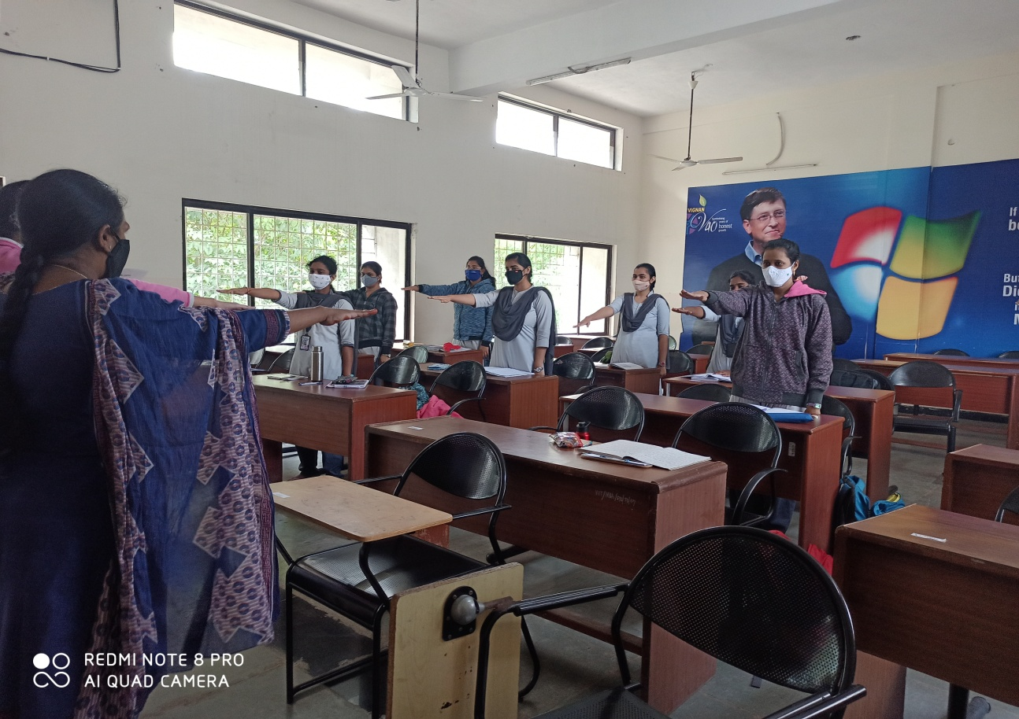

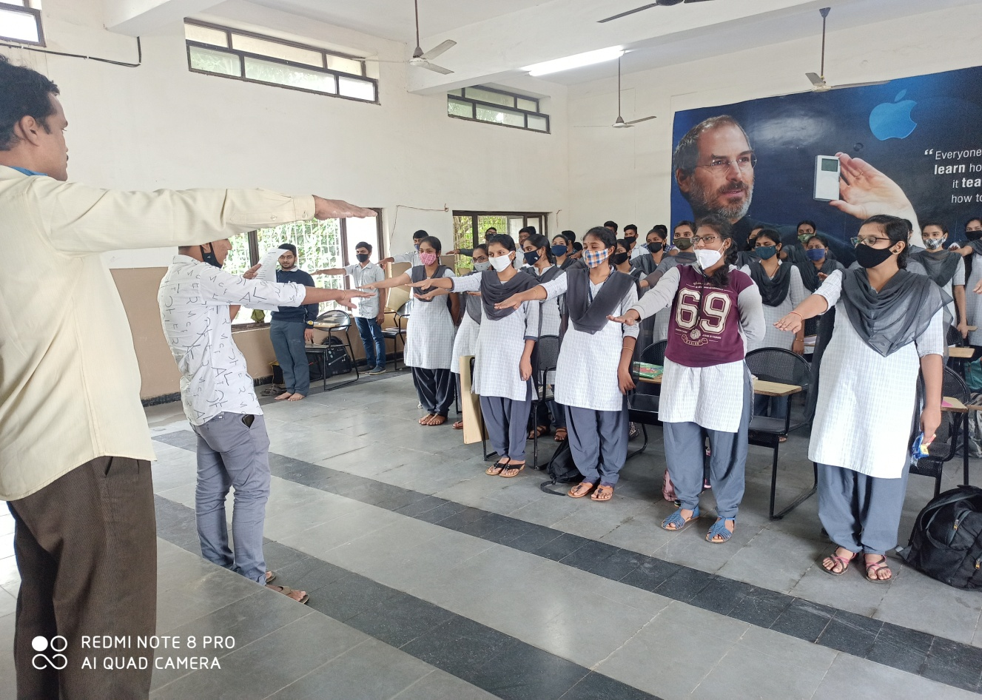

Reading of Preamble by B.Pharm and Pharm D students

