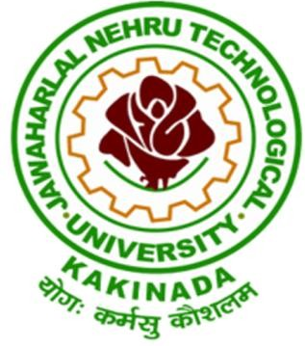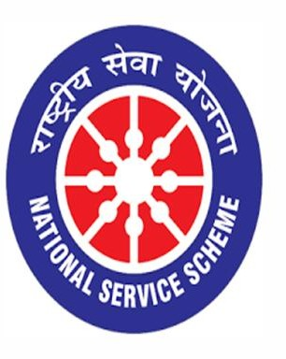

NATIONAL POLLUTION CONTROL DAY 02/12/2020

VIGNAN INSTITUTE OF PHARMACEUTICAL TECHNOLOGY
www.vignanpharma.com (Approved by AICTE, PCI New Delhi & Affiliated to JNTUK). Estd.2006.
An ISO 9001:2015, ISO 14001:2015, OHSAS 18001:2007 Certified Institution
Beside VSEZ ,Kapujaggaraju peta Duvvada, Visakhapatnam-530049. A.P
Phone 0891-2511222/2589777, Fax: 0891-2752333:: email : viptvizag@gmail.com

NOTICE

Date: 30/11/2020

NSS unit of Vignan Institute of Pharmaceutical Technology going to conduct various activities on Dec 2nd on the occasion of National Pollution Control Day under SWACHHTA ACTION PLAN. On this day NSS Unit of VIPT organizing events like Essay writing, Elocution, Painting and Model Exhibit Competition for students. To instill awareness among the people about environmental pollution, the institute going to observe one day as “Say No to Vehicle” on Dec 2nd. All the students and faculty are informed to participate in this event.

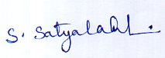
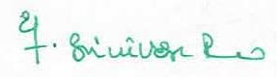
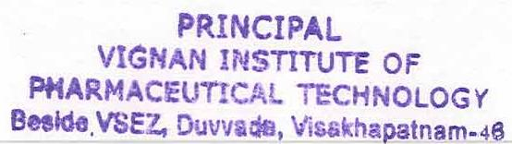
NSS Coordinator Principal

VIGNAN INSTITUTE OF PHARMACEUTICAL TECHNOLOGY
www.vignanpharma.com (Approved by AICTE, PCI New Delhi & Affiliated to JNTUK). Estd.2006.
An ISO 9001:2015, ISO 14001:2015, OHSAS 18001:2007 Certified Institution
Beside VSEZ,Kapujaggaraju peta Duvvada, Visakhapatnam-530049. A.P
Phone 0891-2511222/2589777, Fax: 0891-2752333:: email : viptvizag@gmail.com

REPORT

Date: 02/12/2020

- Competitions for students were conducted both online and off line.
- More than 50 number of students were participated in each event.
- “Say No to Vehicle” was observed on this day.
- Students came to college by cycle to make the campus pollution free for one day.

NSS Coordinator Principal
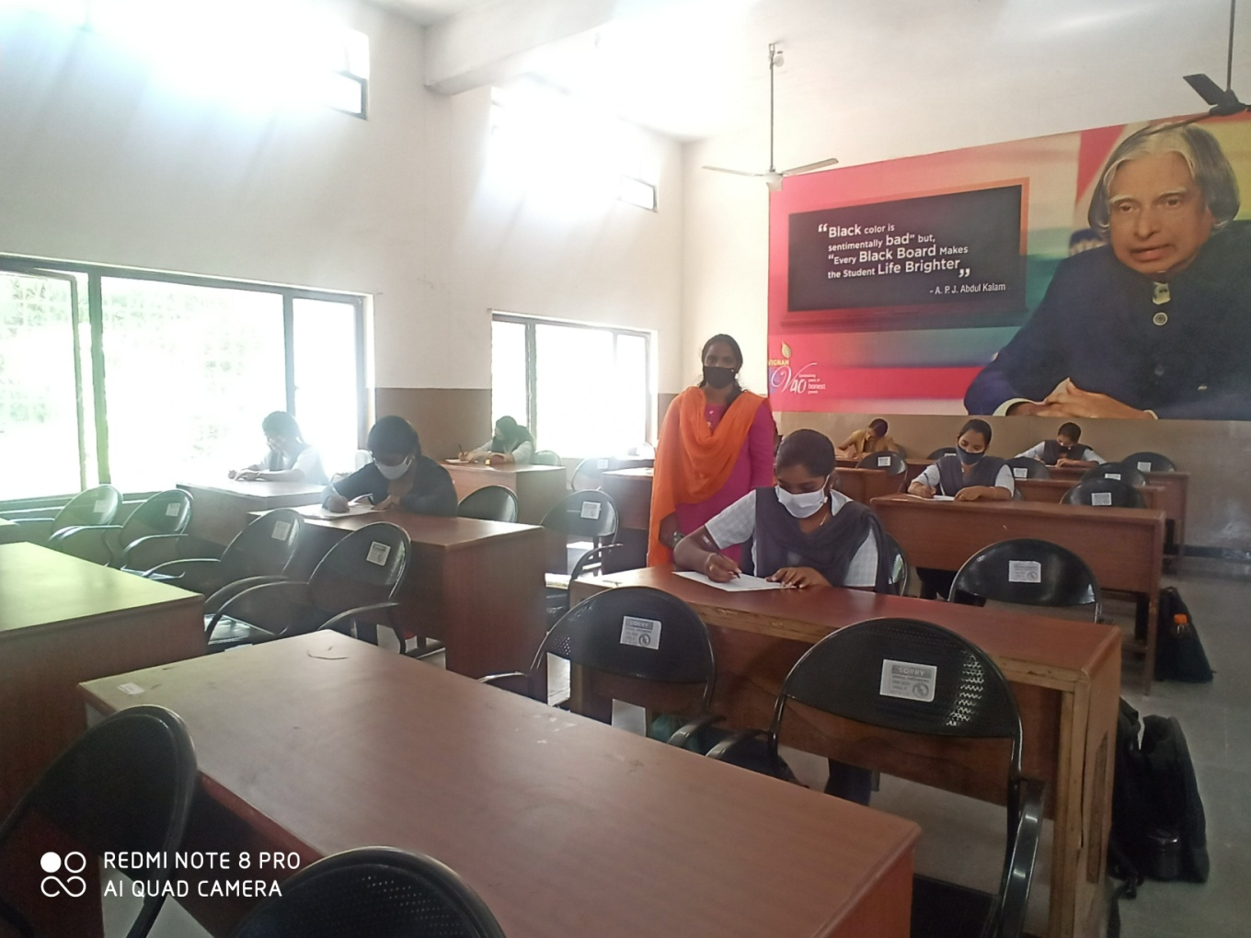
Essay writing and Elocution Competition 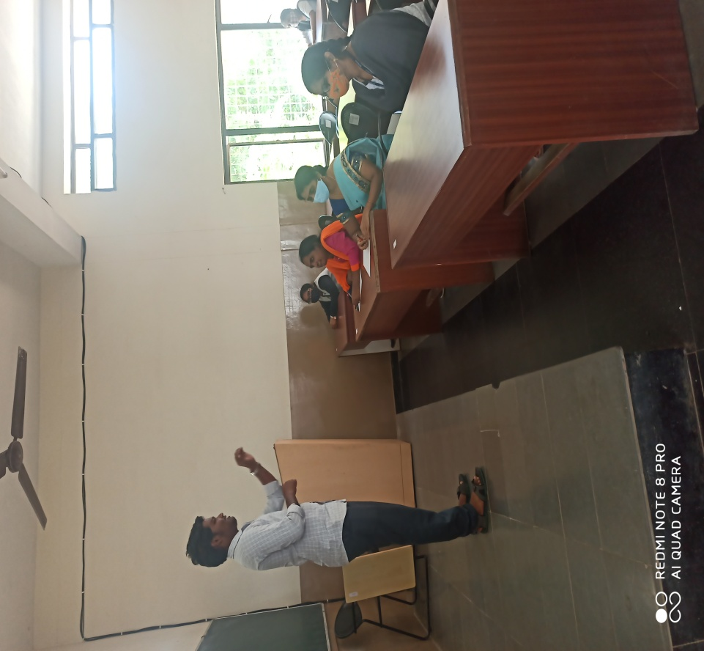

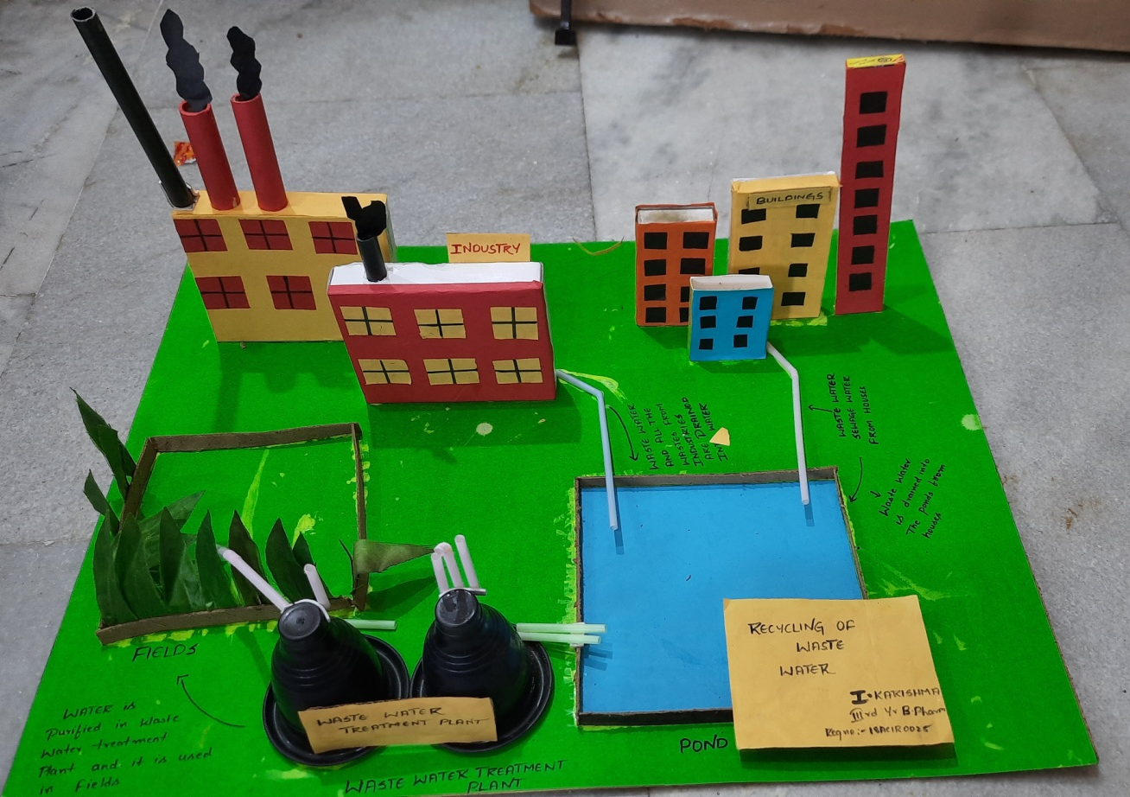
Model exhibit presentation by students
Painting by students 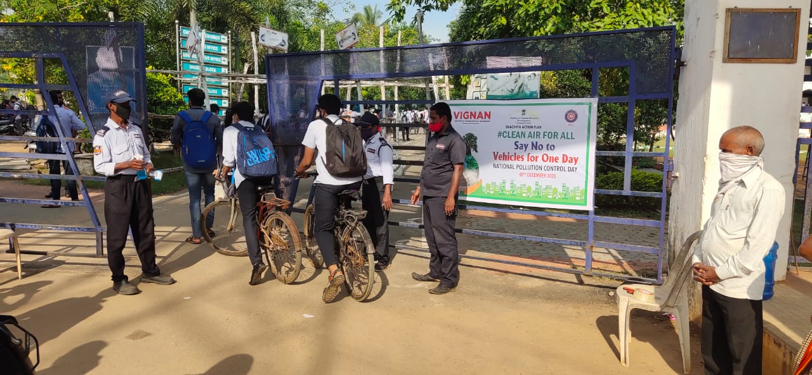
Say No to Vehicle for One Day
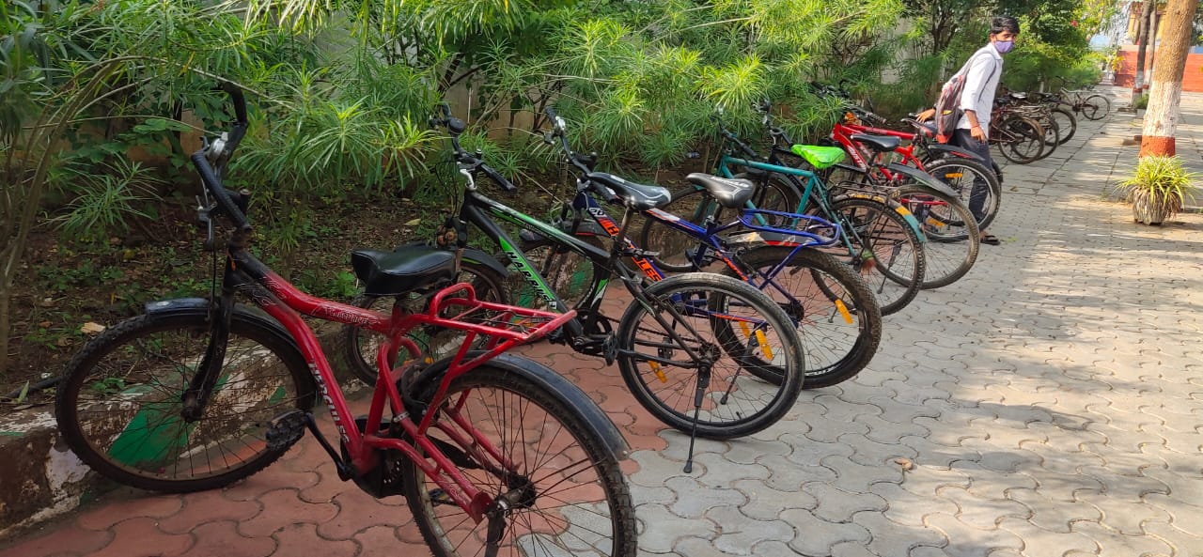

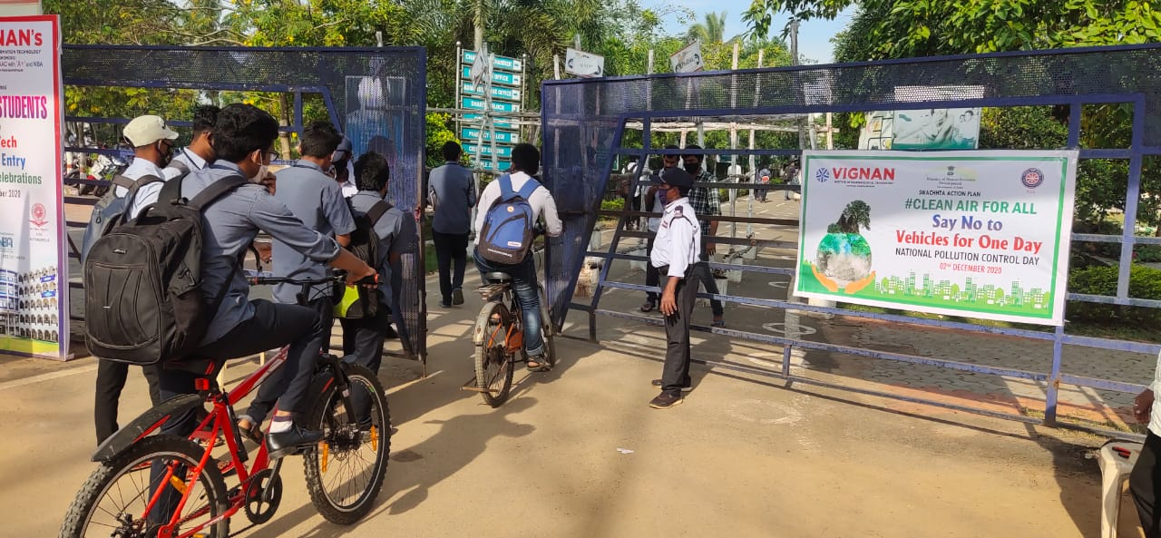

Say No to Vehicle for One Day
