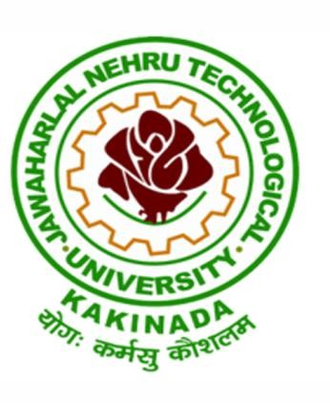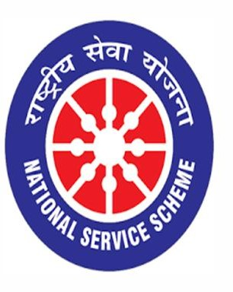

FREE MEDICAL CAMP

01/10/2019
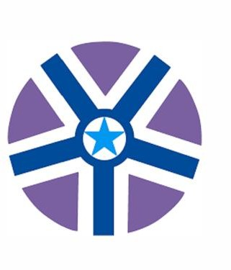

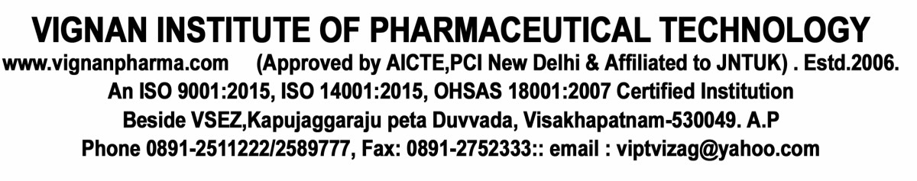

VIGNAN INSTITUTE OF PHARMACEUTICAL TECHNOLOGY
www.vignanpharma.com (Approved by AICTE,PCI New Delhi & Affiliated to JNTUK) . Estd.2006.
An ISO 9001:2015, ISO 14001:2015, OHSAS 18001:2007 Certified Institution
Beside VSEZ,Kapujaggaraju peta Duvvada, Visakhapatnam-530049. A.P
Phone 0891-2511222/2589777, Fax: 0891-2752333:: email : viptvizag@gmail.com

NOTICE

Date: 24/09/2019

NSS unit of Vignan Institute of Pharmaceutical Technology going to organize free medical camp at Narava on 01/10/2019 in association with Rotaract Club. Nearly 48 NSS volunteers and faculty members are participating in this event.
Services Offered in Medical Camp are:
Basic health checkups
Blood Pressure
Body Mass Index (BMI)
Lab tests
Blood glucose
Haemoglobin level
RBC level
Eye Check-up and Free Cataract Surgeries to Poor People
In association with KIMS ICON Hospital

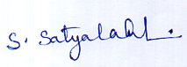
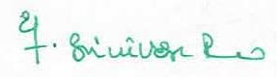
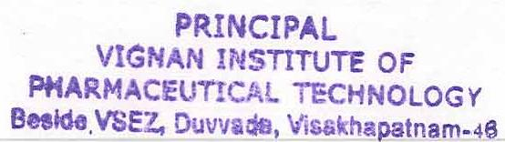
NSS Coordinator Principal

VIGNAN INSTITUTE OF PHARMACEUTICAL TECHNOLOGY
www.vignanpharma.com (Approved by AICTE,PCI New Delhi & Affiliated to JNTUK) . Estd.2006.
An ISO 9001:2015, ISO 14001:2015, OHSAS 18001:2007 Certified Institution
Beside VSEZ,Kapujaggaraju peta Duvvada, Visakhapatnam-530049. A.P
Phone 0891-2511222/2589777, Fax: 0891-2752333:: email : viptvizag@gmail.com

REPORT

Date: 01/10/2019

A medical camp was organized by the NSS unit of Vignan Institute of Pharmaceutical Technology in Narava on 01/10/2019 in association with Rotaract Club. Also organized dental and eye check-up to the villager in association with KIMS ICON Hospital.
The program was a success. Nearly 250 of residents were offered services and corresponding medicines for free. Basic health checkups (BP, BMI) and lab tests like Blood glucose, Haemoglobin level, RBC levels etc were conducted to all the visitors.

NSS Coordinator Principal

