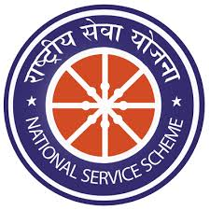

International Yoga Day
21 June 2020

Visakhapatnam 20/06/2020
NOTICE
In view of International Yoga Day VIPT NSS Unit organising virtual yoga session for students on 21st June 2020 at 7.00 am. We invite all the students and faculty of VIPT to join for this session from your home with your family.
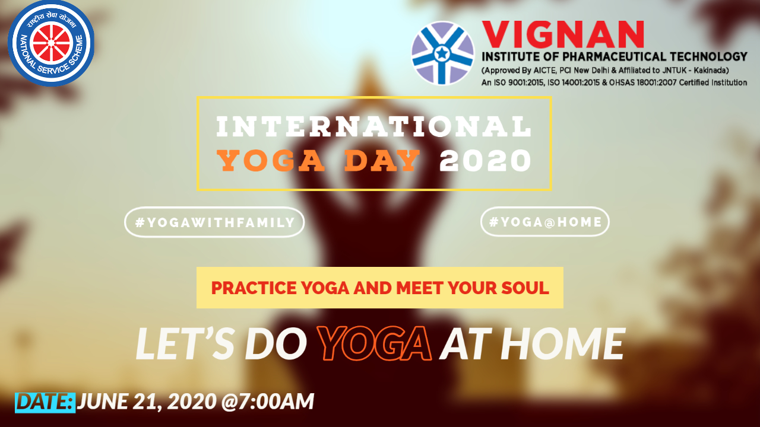

YouTube link: http://youtu.be/Abii11R0cf4

Visakhapatnam 24/06/2020
REPORT
Vignan Institute of Pharmaceutical Technology, Duvvada, Visakhapatnam organized online yoga practice session under NSS activity on International yoga day and uploaded video in you tube. 400 members were viewed the video on that day and participated in the event with their family members at home.

YOGA WITH FAMILY AT HOME

