Yoga Training
22nd June to 6th September

VIGNAN INSTITUTE OF PHARMACEUTICAL TECHNOLOGY
www.vignanpharma.com (Approved by AICTE, PCI New Delhi & Affiliated to JNTUK). Estd.2006.
An ISO 9001:2015, ISO 14001:2015, OHSAS 18001:2007 Certified Institution
Beside VSEZ ,Kapujaggaraju peta Duvvada, Visakhapatnam-530049. A.P
Phone 0891-2511222/2589777, Fax: 0891-2752333:: email : viptvizag@gmail.com

NOTICE

Date: 21/06/2019

Vignan Institute of Pharmaceutical Technology conducting 45 days Yoga Training Programme to all the girl students every day evening at 3.00 pm. Students who wish to join in Yoga Training Classes can register their names.

Yoga Trainer: Mrs K. Anita Devi

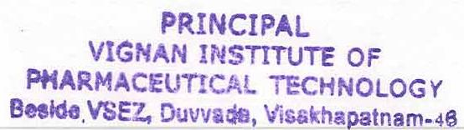
WPC In charge Principal

VIGNAN INSTITUTE OF PHARMACEUTICAL TECHNOLOGY
www.vignanpharma.com (Approved by AICTE, PCI New Delhi & Affiliated to JNTUK). Estd.2006.
An ISO 9001:2015, ISO 14001:2015, OHSAS 18001:2007 Certified Institution
Beside VSEZ,Kapujaggaraju peta Duvvada, Visakhapatnam-530049. A.P
Phone 0891-2511222/2589777, Fax: 0891-2752333:: email : viptvizag@gmail.com

REPORT

Date: 07/09/2019

Mrs.K.Anita Devi taught yoga classes every day for 45 day.
Students were benefited by practicing yoga and overcame some health problems.
Yoga helped them to overcome stress and anxiety.
Some students practiced the yoga moves to reduce asthma and allergy.
They practiced pranayama to improve their concentration and memory.

WPC In charge Principal

